### 

**School of Electrical**

**and Electronic Engineering**



**Robot Orchestra**

**Final Report**

**Group 11**

|  |  |  |
| --- | --- | --- |
| Group Members: | Buruiana, Andrei | 9478411 |
|  | Chanda, Joyanto | 9015629 |
|  | Dimou, Theodoros | 9126435 |
|  | Fumagalli, Francesco | 9017237 |
|  | Petrovs, Antons | 9474345 |
|  | Simpson, Joshua | 8929879 |

Tutors: Prof. Danielle George and Dr. William McGenn

Date: 15 May 2018

# Executive Summary

This report presents the work undertaken by MEng Team 11 on the “New core infrastructure for the Robot Orchestra” project. The MEng project combines engineering with music and art into a single application that can appeal to a wide audience and advertises engineering to people who might not normally consider it. This final year project was motivated by the rising public and industrial interest in the existing Robot Orchestra which, when expanded with the new core, will benefit from increased usability, flexibility and reliability, being able to showcase industrial-standard equipment in an exciting non-traditional way.

The aim of the project was to increase the existing orchestra’s capabilities and allow for a wider selection of musical styles to be played while also allowing for the new instruments to be used as a standalone band. The objectives of the project were to select, design, manufacture and integrate four new instruments, as well as an electronic conductor, and assemble them into a core orchestra that can together play at least two recognisable songs. The instruments that have been developed for this project are: a keyboard, stepper motors, Tesla coils, all using a Teensy board as a controller and a novel xylophone that uses a National Instruments’ MyRIO. The electronic conductor is based on a Raspberry Pi that sends all the necessary information to each instrument via WiFi. The instruments can play both individually as well as jointly songs such as *Californication* by the *Red Hot Chilli Peppers, Eye of The Tiger* by *Survivor* and the *Game of Thrones Main Theme*. The system has been designed with expandability in mind, allowing for future songs and instruments to be easily added. Additionally, it has been designed to allow for easy transportation and set up, making it suitable for use in many different locations and venues.

The project showcases the operation of multiple embedded systems to perform a shared task and it has a dual commercial applicability. First, the orchestra can be used at trade shows and other expo events by technology companies such as National Instruments (MyRIO), ARM (Teensy Board) or Broadcom (Raspberry Pi) to showcase their products that are being used in this atypical application. Secondly, as the project can raise the profile of engineering, it can support corporate social responsibility agendas as well as the government’s STEM initiatives. The combination of engineering and arts developed as part of this project can also serve as an aid for universities to promote their courses as it promotes engineering to an audience of different age categories and backgrounds.

The report concludes that the project has been completed successfully, having met all the requirements set in the initial project brief. The instruments can play two recognisable songs, are easy to transport and set up and the designed conductor ensures that future additions of instruments can be made. In terms of future work, the orchestra could be enhanced with wind and string instruments which the orchestra currently misses. Additionally, adapting the orchestra to play other recognisable songs could prove beneficial as it would increase its’ visibility and potential to draw a crowd at industry-related events.

Table of Contents

[1. Executive Summary i](#_Toc513733920)

[2. Introduction 5](#_Toc513733921)

[2.1. Motivation 5](#_Toc513733922)

[2.2. Aims and Objectives 5](#_Toc513733923)

[2.2.1. Aims 5](#_Toc513733924)

[2.2.2. Objectives 5](#_Toc513733925)

[2.3. Literature Review 6](#_Toc513733926)

[2.3.1. Music review 6](#_Toc513733927)

[2.3.2. MIDI files 6](#_Toc513733928)

[2.3.3. Communication between Instruments and Conductor 7](#_Toc513733929)

[2.3.4. Keyboard 8](#_Toc513733930)

[2.3.5. Xylophone 9](#_Toc513733931)

[2.3.6. Stepper Motors 10](#_Toc513733932)

[2.3.7. Tesla Coil 11](#_Toc513733933)

[2.3.8. Potential instruments 11](#_Toc513733934)

[2.3.9. SN74HC595 Shift Registers 12](#_Toc513733935)

[2.3.10. Decision on instruments 13](#_Toc513733936)

[2.4. Project Roles 13](#_Toc513733937)

[2.5. Required Skills 14](#_Toc513733938)

[2.6. Interdependencies 14](#_Toc513733939)

[2.7. Report Structure 15](#_Toc513733940)

[3. Technical Chapters 16](#_Toc513733941)

[3.1. Anvil Studio 16](#_Toc513733942)

[3.2. Conductor Overview 16](#_Toc513733943)

[3.2.1. SDManager 16](#_Toc513733944)

[3.2.2. Bithoven 17](#_Toc513733945)

[3.2.3. Wireless Network 17](#_Toc513733946)

[3.2.4. Summary 18](#_Toc513733947)

[3.3. Instrument Software Overview 18](#_Toc513733948)

[3.3.1. Initial setup 18](#_Toc513733949)

[3.3.2. WiFi module 18](#_Toc513733950)

[3.3.3. playTrack 19](#_Toc513733951)

[3.3.4. Playing a track 19](#_Toc513733952)

[3.3.5. listTrack 19](#_Toc513733953)

[3.4. Keyboard 19](#_Toc513733954)

[3.4.1. Overall design description 20](#_Toc513733955)

[3.4.2. Solenoid Selection 21](#_Toc513733956)

[3.4.3. Supporting the Solenoids 22](#_Toc513733957)

[3.4.4. Solenoid PCB design 23](#_Toc513733958)

[3.4.5. Supporting the Bosch Bar 23](#_Toc513733959)

[3.4.6. PCB Support Plate 25](#_Toc513733960)

[3.4.7. Keyboard Software 25](#_Toc513733961)

[3.4.8. Structure of the program 26](#_Toc513733962)

[3.4.9. Keyboard Testing 27](#_Toc513733963)

[3.4.10. Keyboard summary 27](#_Toc513733964)

[3.5. Xylophone 27](#_Toc513733965)

[3.5.1. Solenoid choice and bracket design 28](#_Toc513733966)

[3.5.2. Design of Bosch Bar Supports 28](#_Toc513733967)

[3.5.3. Piezo Sensors 29](#_Toc513733968)

[3.5.4. Xylophone Transistor Circuit 29](#_Toc513733969)

[3.5.5. Comparator circuit 29](#_Toc513733970)

[3.5.6. PCB Mounting Plate 30](#_Toc513733971)

[3.5.7. Xylophone Software for Solenoids 30](#_Toc513733972)

[3.5.8. Xylophone Software for Piezo Sensors 31](#_Toc513733973)

[3.5.9. Speaker 32](#_Toc513733974)

[3.5.1. Xylophone Testing 33](#_Toc513733975)

[3.5.2. Summary 34](#_Toc513733976)

[3.6. Stepper Motors 34](#_Toc513733977)

[3.6.1. Stepper Motor Hardware 34](#_Toc513733978)

[3.6.2. Acoustic box 34](#_Toc513733979)

[3.6.3. Digital Signal Synthesizer 36](#_Toc513733980)

[3.6.4. Motor Driver Board 36](#_Toc513733981)

[3.6.5. Stepper Motor Software 37](#_Toc513733982)

[3.6.6. Stepper Motors Testing 37](#_Toc513733983)

[3.7. Decision on Fourth Instrument 37](#_Toc513733984)

[3.7.1. Panpipes 37](#_Toc513733985)

[3.7.2. Research and testing for the tesla coil 38](#_Toc513733986)

[3.7.3. Issues found while testing 40](#_Toc513733987)

[3.7.4. Possible Solutions 40](#_Toc513733988)

[3.7.5. Decision between Tesla coil and Panpipes 41](#_Toc513733989)

[3.8. Tesla Coil progress 41](#_Toc513733990)

[3.8.1. Heat sink calculations 41](#_Toc513733991)

[3.8.2. Component specification 41](#_Toc513733992)

[3.8.3. Testing PCBs 42](#_Toc513733993)

[3.8.4. Testing 43](#_Toc513733994)

[3.8.5. Summary 43](#_Toc513733995)

[4. Summary 43](#_Toc513733996)

[4.1. Achievements compared to Aims and Objectives 43](#_Toc513733997)

[4.2. Progress against GANTT chart presented in Interim Report 43](#_Toc513733998)

[4.2.1. Block 3 43](#_Toc513733999)

[4.2.2. Block 4 44](#_Toc513734000)

[4.2.3. Block 5 44](#_Toc513734001)

[4.3. Future Work 44](#_Toc513734002)

[4.4. Management of the Project 45](#_Toc513734003)

[4.4.1. Meetings 45](#_Toc513734004)

[4.4.2. Procurement 45](#_Toc513734005)

[4.4.3. Outreach Activities 46](#_Toc513734006)

[5. Conclusion 46](#_Toc513734007)

[6. References 47](#_Toc513734008)

[7. Appendices 50](#_Toc513734009)

[7.1. Project Proposal 50](#_Toc513734010)

[7.2. MIDI Notes 54](#_Toc513734011)

[7.3. Interim Report 55](#_Toc513734012)

[7.4. Notes required by Keyboard 56](#_Toc513734013)

[7.5. Amount of force required to play a key 56](#_Toc513734014)

[7.6. Diagrams for supporting structure on the keyboard instrument 57](#_Toc513734015)

[7.7. Keyboard Testing 58](#_Toc513734016)

[7.8. Diagrams for structure on Xylophone 59](#_Toc513734017)

[7.9. Front panel of LabVIEW code 63](#_Toc513734018)

[7.10. Code for 12 keys to produce sounds 64](#_Toc513734019)

[7.11. PCB for Audio Amplifier Circuit 65](#_Toc513734020)

[7.12. Appendix L 65](#_Toc513734021)

[7.13. DRV8825 Driver board Schematic 65](#_Toc513734022)

[7.14. Mini Tesla Coil Instruction Sheet 66](#_Toc513734023)

[7.15. Minutes and Agenda 68](#_Toc513734024)

[7.16. Procurement 68](#_Toc513734025)

[7.17. Feedback sheets from Faraday Event 68](#_Toc513734026)

# 

# Introduction

The University of Manchester Robot Orchestra was created in 2016 to celebrate Manchester becoming the European City of Science. The objective behind the orchestra is to show that a range of technical engineering skills can be used to create something that is accessible to a mass audience, which hopefully inspires more young people to pursue a career in the technical sciences. Since it was created, the orchestra has gone on to feature in a popular BBC iPlayer documentary [1], played at the Museum of Science and Industry in Manchester and gained backing from Siemens, EPSRC, The Granada Foundation and National Instruments [2]. Recently, it has been part of an engineering tour sponsored by the Royal Academy of Engineering. So far, the orchestra has had a positive reception, but the existing infrastructure of the orchestra makes it hard to use, time consuming to set up and difficult to add new songs. This project has been dedicated towards developing a new stand-alone core infrastructure (conductor and instruments) that can be used by themselves and with the existing instruments.

## Motivation

The existing orchestra is difficult and time consuming to set up as all the instruments are wired to the conductor. Additionally, the reliability and capability of the instruments is limited as the instruments are developed by schoolchildren and it is difficult and laborious to add new songs to be played as the instruments do not use a common music file format. Because of this, increasing the orchestra’s capabilities by adding new instruments that use the same music file format and a conductor that automates the conversion process between the music file and each instrument would lead to a more reliable orchestra that is easier to set up and expand with new instruments. This would also allow for a wider selection of musical styles to be played and would lead to the orchestra appealing to a broader audience. In addition to its outreach aspect, the orchestra also showcases the operation of multiple embedded systems to perform a shared task, making use of platforms such as MyRIO, Raspberry Pi and microcontrollers to play recognisable songs.

As there is a high interest in attracting students to study STEM degrees and as it can be difficult to explain the benefits of such a degree to an audience of different backgrounds and age categories, the orchestra can serve as a good aid for universities to promote their courses and advertise engineering to people who normally would not consider it as it combines engineering and art into a single application. Additionally, the orchestra can also be used by companies in the technology industry at trade fairs to illustrate the creative aspects of engineering and to showcase the applications of their products in an atypical project.

## Aims and Objectives

### Aims

According to the proposal given by the project tutors (Appendix 7.1), the main goal is to develop 4 new robot instruments that will be controlled by a conductor. This should form a new standalone robot orchestra that can play at least 2 pieces of music and should be flexible and allow for new additions of songs or instruments in the future. As the title implies, this is a robot orchestra and it should operate at a high level of autonomy where the only interaction should be the user of the orchestra picking the songs using the GUI designed to interact with the conductor. The MIDI format, which is a standard format for electronic music files, will be used as a common format for all the songs played in this project.

The orchestra should stick to a certain engineering aesthetic as it is meant to promote STEM aspects and to appeal to audiences that are not traditionally associated with engineering. Other goals outlined by the proposal are to make sure the orchestra is easily transportable in order to take it to different places and events.

### Objectives

The objectives of the project are as follows:

1. Selecting four new instruments:

* Looking at different songs that could incorporate 4 robot instruments then breaking down the notes needed for each instrument.
* Picking two songs as well as the 4 instruments that will be playing those songs.

1. Designing and constructing the four instruments:

* Proposing designs for the instruments as well as ideas for their communication with the conductor while considering transportation and modularity.
* Using CAD to design hardware and then producing prototypes.
* Designing and testing breadboard circuits and converting to PCBs.
* Printing the PCBs and making sure they work with the software like the breadboard circuits.
* Constructing the hardware.
* Testing the instruments and making sure they play all the notes at the right tempo.

1. Designing a conductor:

* Deciding on an embedded system for the conductor.
* Designing the conductor which will communicate with the instruments.
* Communicating with each instrument using the conductor.
* Designing the GUI.
* Receiving “Play” and “Stop” from the GUI and sending those commands to the instruments.

1. Synchronising the 4 instruments to play coherent music.

## Literature Review

During the first project block in Semester 1, the team was split into individual sub teams where each team was responsible for researching an instrument. Once the research period was over, another meeting was held to discuss potential instruments.

Currently the Manchester Robot Orchestra contains a drummer, an instrument made from floppy drives and a robot that plays the Glockenspiel [3]. Since these instruments have already been created they will not be considered as potential instruments for the new expansion.

Whilst conducting research there were limited scientific journals or articles about projects like this. Where they were found, they have been incorporated in this project but given the nature of the project some resources from hobbyists and non-scientific projects were also included as they proved to be beneficial.

### Music review

Musical notes are put into octaves which contain 8 notes. There are also 5 flats or sharps in an octave, but the major scale goes from one C to the next C in the order C-D-E-F-G-A-B-C, where if the first C is C1 then last C would be C2 [4]. Every subsequent C has a frequency that is roughly double its predecessor. The progression of these Cs and their notations can be seen in Figure 2.1. More information on musical notes and scales can be found in the interim report (Section 3.9 of Appendix 7.3)

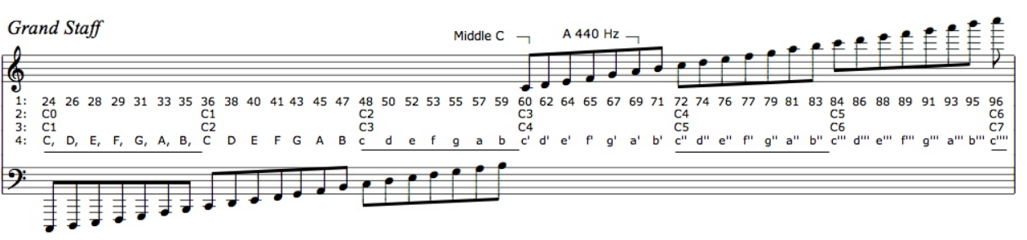

Figure 2.1. Musical notes according to MIDI and scientific notation [5].

### MIDI files

MIDI stands for Musical Instrument Digital Interface and is used to encode all the data required to replicate a song under a common format. MIDI files specify which note to play, for how long and with what velocity the instrument is to play the note [6] [7]. MIDI has become a standard interface used in the music industry and will be used in the project to acquire songs. MIDI files for a vast number of songs can be easily found online, allowing the team to easily choose any song available. It is also an easy way for musicians to write music for the orchestra.

Each MIDI file consists of a *Header Chunk* and *Track Chunk*. The header chunk specifies various parameters needed to decode the rest of the file. It is constructed as follow [2][3][5]:

|  |  |  |  |  |  |
| --- | --- | --- | --- | --- | --- |
| **Length** | *4 bytes* | *4 bytes* | *6 bytes* | | |
| **Value** | *‘MThd’* | *Length (6bytes)* | *FF FF* | *NN NN* | *TT TT* |

Table 1 Header chunk

The top row in Table 1 indicates the size allocated to each section of the header. The bottom row contains the data.

The remaining MIDI file consists of the *Track Chunk* Table 2 shows its layout.

|  |  |  |  |  |
| --- | --- | --- | --- | --- |
| **Length** | 4 bytes | 4 bytes | Variable depending on specified length | |
| **Value** | *‘MTrk’* | *Length* | *Delta time* | *Event* |

Table 2 MIDI Track Chunk

More information on the header chunk and MIDI track chunk can found in Section 3.8 of the Interim Report (Appendix 7.3).

The track event can either be a MIDI, meta or sysex events. For this project, only MIDI events need to be considered. MIDI events contain messages sent to each individual channel (instrument) and contain the note and status information. MIDI events consist of three bytes, the first byte is known as the status byte and its function is to specify the type of command, for our purpose only two commands will be used, *press* and *release* which tell the instrument to either play or release the note. Although other commands exist for instruments with additional features like pedals, they will not be considered as the instruments chosen do not require them. The second byte specifies the note to which the status byte is applied to and the third byte specifies the note velocity (loudness or softness). A table showing the musical note to which each binary value corresponds to can be found in Appendix 7.2. [8] [9] [10]

|  |  |  |  |
| --- | --- | --- | --- |
| **Length** | 1 byte | 1 byte | 1 byte |
| **Function** | Status Byte | Note Number | Note Velocity |

Table 3 Track events

### Communication between Instruments and Conductor

#### Choice of network

The choice of telecommunication method was narrowed down to three choices: WiFi, Bluetooth and Radio (2.4GHz); the pros and cons will be examined, and a decision will be made in this section.

In order to control the instruments that will be built in this project a variety of microcontrollers are being investigated, some of which do not have built in WiFi/Bluetooth/rf so the modules would have to be bought. The Raspberry Pi has built-in WiFi and Bluetooth but not RF. However, the price for the modules is relatively low (£3-5) compared to the budget so it did not play a major role in the decision.

The second aspect the team examined were the libraries and documentations available for each module both for the Raspberry Pi and the various microcontrollers being considered. All three modules are heavily documented and have libraries available, however, only the WiFi had many protocols for building a network between several nodes and a server. Bluetooth is harder to build a network with and RF does not have a specific protocol for networks of this nature. However due to the nature of the modules (nRF24L01+) a network can be easily built by exploiting the various channels available. WiFi did stand out regarding the availability and simplicity of the protocols for building networks. Moreover, the RPi’s built-in WiFi would speed development and WiFi modules are cheap and can easily be integrated with any microcontrollers which have *Universal Asynchronous Receiver Transmitter* (UART), more on the WiFi modules can be found in Section 3.2.2. Due to these reasons, WiFi was chosen as a base to build the network on.

#### MQTT Protocol

MQTT (Figure 2.1**.**), which stands for Message Queuing Telemetry Transport is a lightweight messaging protocol for small sensors and mobile devices which follows a publish-subscribe messaging protocol and works on top of the TCP/IP stack, which is a series of protocols that allow two computers to communicate with one another. MQTT is becoming an industry standard within the I.O.T (Internet of Things) ecosystem due to its simplicity and the fact that it is extremely lightweight and can run on almost all systems.

MQTT is based on a client-server model where the client is connected to a server and receives messages from it, an MQTT server is known as a ‘broker’. Clients can *‘publish’* and *‘subscribe’* to *‘topics’*. Any client can publish to any topic and other clients which have subscribed to the same topic will receive the messages. The operation of the MQTT protocol can be seen in Figure 2.1.

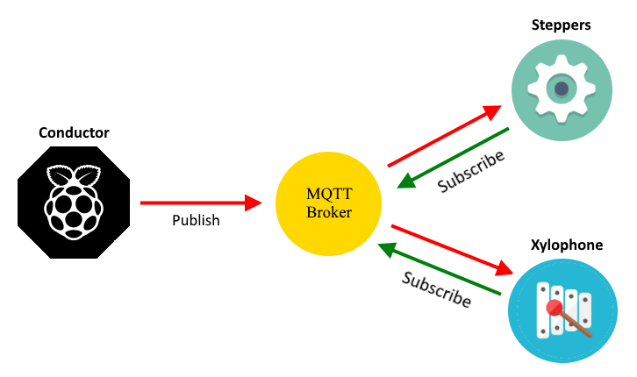

Figure 2.2 Network based on the MQTT protocol that could potentially be used for the orchestra.

### Keyboard

A piano (or keyboard in the case of this project) is a very traditional instrument. Creating a robot to play the keyboard contributes to the philosophy of unifying engineering and art to make the robot orchestra more accessible to a larger audience. To research this, several designs were reviewed and a paper by *Sugano* and *Kato* was reviewed [11].

In their paper, the authors aim to progress in the field of “soft robotics” [11] by creating two robotic hands that are capable of playing the keyboard by moving like human hands. To design a robot that can do this it is important to consider the degrees of motion that a robot must go through to play the keys. As *Sugano* and *Kato* explain, there are four primary degrees of freedom which occur at the three joints in the finger (MP, PIP and DIP in Figure 2.2) and the wrist.

|  |  |
| --- | --- |
| Figure 2.3 (a) Degree of freedom found in the finger and thumb in a human [11] | (b) Robotic hand proposed by *Sugano* and *Kato* [11] |

The DIP joint can be neglected because it is only used whenever the PIP joint is active, and it serves no purpose when pressing a key down on a keyboard [11]. The PIP joint differentiates between a white key and a black key on the keyboard with the MP joint being responsible for pressing down on the selected key. The wrist is responsible for rotating the entire hand to give the fingers access to more keys. Reducing these degrees of freedom would aid in making sure the four instruments in this project are completed on time. The design shown in Figure 2.3 is an example of a robot playing a keyboard where the PIP and wrist joint have been limited and fixed in place, with the MP joint controlled by solenoids that push down on the keys.

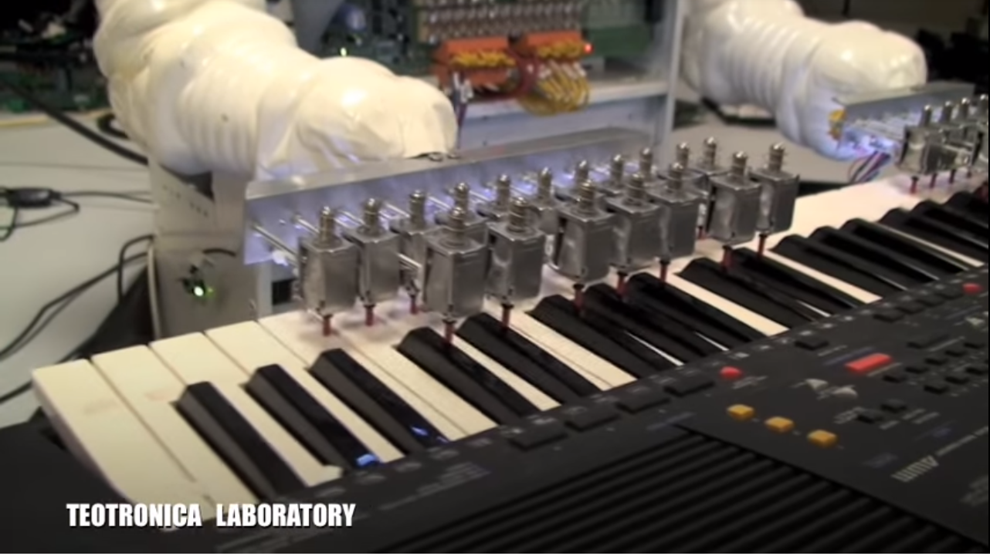

Figure 2.4 Teotronica robot keyboard [12]

The benefit of this type of design is that is significantly simpler to construct, both in terms of hardware and software, than the design proposed in [11]. By fixing the PIP and wrist [11] joint in place, only the MP joint has to be controlled through the software. However, fixing these two joints in place significantly reduces the flexibility of the instrument. The design shown in Figure 2.3 can only play the note that the solenoids are fixed above. If a song requires any additional notes, then additional hardware must be constructed. In addition to this, the design will look less human like which may, dependent on the observer, reduce the aesthetic appeal. For application in this project, simplifying the hardware is more important than creating a design that is human-like as the sound the orchestra produces is the most important metric whereas in [11] the aim was to create an anthropomorphic design. Also, simplifying the design reduces the time spent on each instrument allowing more time for the other instruments to be designed and reducing the chance that instruments will not be completed.

### Xylophone

The xylophone is part of the percussion family and consists of wooden bars that differ in size. Each bar is an idiophone (musical instruments which have a resonant solid material that vibrates in order to produce sound [13]) and produces various sounds which are dependent on their length, with the shorter bars producing higher notes and the longer bars producing lower notes [14]. The xylophone is traditionally tuned in different octaves dependent on the origin of that specific xylophone. For instance, in Africa and Asia, the xylophone belongs in the pentatonic and heptatonic scale, meaning there are five and seven notes per octave respectively [15] [16]. When it comes to use in an orchestra, the xylophone is tuned in the chromatic scale [17] and hence, contains twelve notes per octave (eight regular notes and 4 sharps).

|  |  |
| --- | --- |
| Piezoelectric sensor  Arduino shield with multiplexer  Board that connect piezos to shield |  |

Figure 2.5 Customised xylophone [18]

There were several designs found online and reviewed, but the team decided to create a customized autonomous xylophone, which is able to produce sounds according to the team’s preferences. That idea is based on a video found on YouTube (Figure 2.5, [18]), where a person created a customized xylophone with eight keys. Each key had a piezoelectric sensor mounted at its centre and was programmed (through an Arduino) to produce a specific sound when it was hit.

The reasons for creating a customised xylophone are as follows; to begin with, it gives the opportunity to reproduce multiple sounds, along with the sound of a xylophone, according not only to the needs of the song, but also to the team’s preferences, i.e. guitar sound, piano sound, and more. Furthermore, according to the selected track, the user can select the appropriate octave, in which the notes will be tuned, resulting in a higher or lower sound. Moreover, the xylophone is full autonomously (in contrast with the one shown in Figure 2.5), having a row of solenoids above its keys. Additionally, the custom xylophone is constructed by Perspex and therefore is transparent, giving in this way, the opportunity to see the “inner” side of the instrument; i.e. all the embedded systems used along with the multiple connections that were made. Finally, the robot orchestra already has a Glock O Bot and therefore the construction of the xylophone acts as a differentiating factor between the two instruments.

### Stepper Motors

As stepper motors produce noise when rotating at different frequencies, the possibility of using them as an unconventional musical instrument was investigated. It was discovered that multiple videos of such an instrument were posted online such as those presented in [19] and [20] which confirmed that the instrument was feasible.

A stepper motor is an electric motor that converts digital pulses into steps of a full rotation [21] and is usually used in high-precision applications that use control signals in the form of digital pulses rather than voltage levels. By varying the frequency of the pulses, the rotation of the shaft can be modified. The key difference between a stepper motor and a servo motor is that the stepper motor does not require a feedback mechanism since there is a direct relationship between a digital pulse and the amount by which the motor shaft rotates [22].

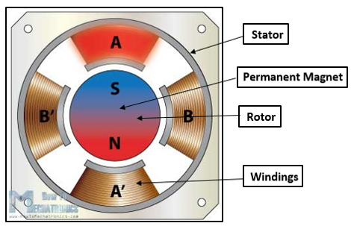

Figure 2.6 Cross section of stepper motor [23]

Figure 2.6 illustrates the cross section of a stepper motor. It can be observed that the permanent magnet in the centre acts as the rotor of the motor and is surrounded by the stator’s windings. To understand how the rotational movement is generated, the rotor and stator will be analysed separately. The rotor consists of two discs placed back to back: one of them acts as the north pole and the other acts as a south pole. The stator is fixed and its windings act as electromagnets that can be independently controlled. When a winding is activated, it attracts the disc of opposite polarity of the rotor and as the windings get activated in turns, this results in the rotational movement of the motor’s shaft being generated [24]

A stepper motor can be controlled in three different ways, depending on the precision that is required. These modes are full step, half step and microstep and the difference between them is represented by the order in which the windings are energised. For example, one digital pulse sent to a motor operating in half step mode produces an angular movement that is half of the one that is obtained by the same pulse when using a motor operating in full step mode.

The key aspect of stepper motors for them to be used as a musical instrument is represented by their ability to generate frequencies in the audible range (20 Hz – 20 KHz [25]) that correspond to musical notes. This is caused by the deformation of the stator lamination stack [26] (new reference added). As a result, a song can be replicated by the stepper motors by sequentially generating the frequencies of the musical notes required and ensuring that they are generated for the correct amount of time.

### Tesla Coil

The Tesla Coil was invented by Nikola Tesla in 1891 as a way to transmit electrical power wirelessly [27]. A tesla coil consists of a primary coil with a low number of turns and a Secondary (tesla) coil of which one side is connected to ground and the other is left as an open circuit [27]. A typical tesla coil circuit is shown in Figure 2.7a and Figure 2.7b. In Figure 2.7 the voltage rises to a point at which a spark can form over the spark gap, at this point the combination of the capacitor primary and secondary inductance causes a high frequency current. This is created the energy oscillates between the capacitor and the primary coil inductance [28]. When there is no spark formed over the spark gap the capacitor charges. There are several disadvantages to this design as when a spark is formed there is a high power and current flow [27]. For DC operation the spark gap is exchanged for a switch which can be controlled to charge the capacitor and then to let it discharge over the primary coil [28].

|  |  |
| --- | --- |
| Figure 2.7 (a) Spark gap Tesla coil circuit | (b) Tesla coil circuit [29] |

The building of a tesla coil can be broken down into several parts: the primary coil, secondary coil, spark gap or switching circuit, capacitors and Toroid [30]. To make a tesla coil play music the switching circuit which charges up the capacitor is controlled using PWM [31]. There are also several descriptions on how to build a tesla coil from amateur enthusiasts [32] [29] [33].

A tesla coil instrument could also be a good idea for the robot orchestra as it can be used as an educational tool. As it can be used to demonstrate electrical fields and the wireless transfer of energy this can be done by holding a bulb close to the coil and it will light up with no connections [34]. Tesla coils can also be used for simulating lightning i.e. testing aircraft however, currently Impulse Voltage generators are more commonly used [35].

There are examples of tesla coils being used to play songs on YouTube, one such example can play ‘the Hall of the Mountain king’ which produces streamers several meters in length. [36]

### Potential instruments

The panpipes were one of the instruments considered. They consist of 15 pipes would be played by blowing air across the openings of the pipes in order to generate notes. According to research done in [37], the pipes would require about 8.5 litres per minute [37] of airflow to play notes the octaves above C6 (if C1 is the first C), making them a good choice to mimic vocals in a song.

Research was done on other wind instruments such as the Waseda Flutist Robot [38] and the Saxophone Playing Robot [39] seen in Figure 2.8a and Figure 2.8b respectively, but due to the complexity of some components such as the artificial lips and lungs this was considered an unfeasible option due to the time constraints of the project as well as the budget.

|  |  |
| --- | --- |
| Figure 2.8 (a) Waseda Flutist Robot [38]. | (b) Saxophone Playing Robot [39]. |

Proof of concept can be seen in video [40] where a set of panpipes is being played by a robot that moves the panpipes across a nozzle that blows air across the pipes producing the corresponding notes. The panpipes are easier to automate since there are less moving parts and Degrees of Freedom (D.o.F) involved compared to the other wind instruments that were feasible.



Figure 2.9 Robot plays the panpipes by moving the panpipes across an air nozzle [40]

### SN74HC595 Shift Registers

There are four ways that shift registers operate, the SN74HC595 is an example of a serial in-parallel out shift register (SIPO). The other three are, Serial-In to Serial-Out (SISO), Parallel-In to Serial Out (PISO) and Parallel-In to Parallel Out (PIPO). The microcontrollers that are being considered for this project all have a limited number of IO pins. Using shift registers, the number of IO pins on any of the microcontrollers can be expanded in multiples of eight.

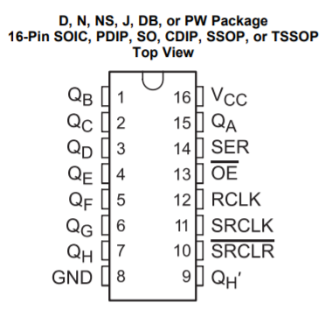

Figure 2.10 Schematic for SN74HC595 shift register from Texas Instruments [41]

From Figure 2.9, there is one *Serial Input* pin located on pin 14 and there are eight output pins located on pins 1-7 (QB to QH) and 15 (QA). To control the shift register, an 8-bit variable is sent, bit by bit, to pin 14 which writes each bit to the corresponding output pins starting at pin 15 (Q­A) and finishing on pin 7 (QH). In this way an 8-bit variable can be written to the shift register. Once this writing process has been completed, pin 12 (latch pin – RCLK) is set high and all the output pins are written to their connections at once. In this way the shift registers allow for control of more output pins than are available on the typical microcontrollers. Several shift registers can be connected in series with one another to act as one large shift register, increasing the number of outputs in multiples of eight. This is done by connecting the *Serial Out* pin (QH’ – pin 9) from one shift register to the *Serial Input* pin (SER – pin 14).

### Decision on instruments

After the initial research period was over, three of the instruments had been decided on. The keyboard was chosen as an instrument due to flexibility it provides the orchestra as it can play a wide range of notes.

The Xylophone was the second instrument to be decided on however, instead of using an actual xylophone the entire design will be bespoke, similar to the design in Figure 2.5. This allows greater control of the look of the instrument as well as increasing the flexibility.

The stepper motors form the third instrument as they have the ability to play a wide range of notes as well having simple and cheap hardware requirements. Four stepper motors will be used, as this was the number typically used in the designs found, and method will be found to amplify the sound as they may be difficult to hear amongst the other instruments.

The fourth instrument, at this stage, was a choice between the Tesla Coil and Panpipe. The Tesla Coil is appealing, as it is useful as an educational tool and the Panpipes are well suited to mimic the vocals of a song.

## Project Roles

Table 4 below shows the roles fulfilled by each of the team members during this project and a brief description of what each of the roles entails. Three roles have been added to reflect the nature of the project, they are the *Hardware Lead*, *Software Lead* and *Document Controller.*

|  |  |
| --- | --- |
| **Project Manager**  **(Joyanto Chanda)** | The project manager role is responsible for developing and maintaining the overall project plan. In this project, a GANTT chart was used to determine the current progress of the project against the expected progress. They are also responsible for assigning tasks to team member and acting as the main point of contact with the 4th Year Project Tutor. |
| **Secretary**  **(Joshua Simpson)** | The secretary ensures that all the minutes and agendas are prepared for each of the meetings, both for individual team members and with supervisors. They are also responsible for ensuring that the minutes and agendas are filed away in a manner that makes them easily accessible. |
| **Auditor**  **(Andrei Buruiana)** | The auditor is responsible for managing the project budget by maintaining an accurate record of all expenditure in the project. They are responsible for maintain an acceptable standard for the workspace and ensuring all equipment is returned or stored away correctly. |
| **Hardware Lead**  **(Theodoros Dimou)** | Important to define the approach to any upcoming hardware deadlines. Also, will be used to make decisions when the team is undecided on the approach to certain hardware challenges. Important to have prior experience in designing hardware (e.g. responsible for the bulk of the hardware design on the buggy project). |
| **Software Lead**  **(Francesco Fumagalli)** | The software lead in this project is a crucial role and was assigned to the person with the most experience of various embedded systems and in coding. They are responsible for defining the structure of the software for each of the instruments and how they will communicate with the conductor. |
| **Document Controller**  **(Antons Petrovs)** | Ensures that documents across the project have a consistent format and are mad easily accessible by each team member. They are also responsible for formatting and organising the two reports. |

Table 4 Project Roles

## Required Skills

In a project like this a range of technical skills will be needed to create the four chosen instruments and the conductor. For example, skills in analogue circuit design, programming in C and a solid understanding in MIDI to text conversion alongside basic musical knowledge.

|  |  |  |  |  |  |  |
| --- | --- | --- | --- | --- | --- | --- |
| Indicates where skills were developed. | | | | | | |
| Degree | **Electronic Engineering** | **Mechatronic**  **Engineering** | | **Electrical and Electronic Engineering** | | |
| Skills | Andrei Buruiana | Antons Petrovs | Francesco Fumagalli | Joshua Simpson | Joyanto Chanda | Theodoros Dimou |
| Analogue Circuit Design | X | X | X | X | X | X |
| Electronic Circuit Design | X | X | X | X | X | X |
| Coding in C | X | X | X | X | X | X |
| Experience with Arduino |  |  | X |  | X |  |
| Experience with MyRIO |  | X |  |  |  | X |
| Experience with Raspberry Pi |  |  | X |  |  |  |
| 3D Modelling |  | X |  |  | X | X |
| PCB Design | X | X | X |  |  |  |
| Basic Music Knowledge |  |  |  | X |  |  |
| Experience in LabVIEW |  | X |  |  |  | X |

Table 5 Breakdown of the team member’s technical skills required for project

During the design phase of the instruments several different embedded systems were considered for each of the instruments. From looking at Table 5 above the team had previous experience in working with the Arduino and working with Raspberry Pi. However, there was no previous experience when working with the National Instruments’ (NI) MyRio. There was deliberation as to whether to include the MyRio as a part of the project because of this reason however, ultimately it was decided that it would form a part of one of the instruments since it provided several benefits. It has significantly more digital IO pins than any of the other embedded systems as well as an in-built Wi-Fi module. In order to address the skills, gap an application was submitted to the NI Student Sponsorship Project. Although we were not successful with the application, once hearing about our project NI still provided a support engineer to help the team in incorporating a MyRio with the orchestra.

## Interdependencies

Figure 2.11 below shows the main tasks for the project that had to be completed and how they relate to one another. The four instruments and the part of the conductor were developed in parallel. Within in each instrument, the hardware and software design occurred in parallel. The dependency within the keyboard, xylophone and tesla was between the *Software Testing* task and the *Hardware Testing* task. In order for the software to be fully tested the hardware testing needed to be completed. There were no interdependencies between instruments, with the exception of the Tesla Coil and Stepper Motors. Since they used the same software to play a track, the completion of the Tesla Coil was dependent on the completion of the *Software Testing* task from the Stepper Motors.

Once the *Software Simulation* task for the Keyboard, Xylophone and Stepper Motors was completed and the Conductor was able to send simple commands, it was possible to work on making the Instruments Communicate with the Conductor. Since the Keyboard and Stepper Motors use the same embedded system and communicate with the conductor in a similar way, it was more acceptable for one of these instruments to be delayed, provided at least one completed their software testing on time. However, since the Xylophone uses a different embedded system to the others, a delay in the completion of the software for this instrument would have had significant impact on the project. It was important to identify this at the beginning of the project as it meant that if the Xylophone was falling behind, resources could be moved from the software development of one of the other instruments in attempt to maintain the schedule for the Xylophone.

The *Synchronisation* task was dependent on the four instruments being able to play songs and communicate with the conductor, as shown in Figure 2.11. This task focuses on making sure the instruments play in time with one another. Once this is completed, the focus is on increasing the aesthetic appeal of the orchestra, so it is ready to present at demo day.

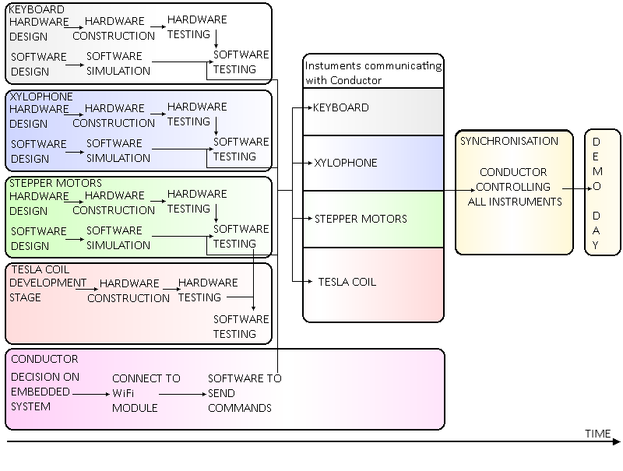

Figure 2.11 Interdependencies amongst tasks

## Report Structure

The report is structured as follows: Section 1 focuses on the aims, objectives, motivation and interdependences of the project. Additionally, it presents the literature review underlining the research done on the conductor and on each instrument of the orchestra. This is an enhanced version of the literature review presented in the Interim Report. Section 2 presents the technical work undertaken for the conductor and for each musical instrument in the orchestra. Following this, Section 3 offers a summary of the work done during the project and analyses the progress made against the GANTT chart presented in the Interim Report. Additionally, it provides available options for future work that can be done for each individual element of the orchestra and also analyses the management of the project. Lastly, Section 4 draws a conclusion on the work presented in this report.

# Technical Chapters

## Anvil Studio

Anvil Studio [42] was the software used to view and edit MIDI files. This software was used to validify the output of the *MIDI2Text* script in order to make sure script is converting the MIDI files to text as intended.

Anvil Studio was also used by the team to breakdown the MIDI files into constituent tracks that contained the different instruments which were used in the song, which played an important role in deciding which songs would be picked. It also allowed editing of the tracks, specifically changing the instrument that played each track which was used make the song sound like it was playing with the four instruments that were picked.

Finally, the software was also used to edit the tracks to test instruments as well as to optimise the songs for the current orchestra.

## Conductor Overview

Part of the specification for the project required the team to build and develop a conductor. The only requirement of the conductor is to synchronise the instruments together. However, the team added additional functionality to allow it to act as a ‘bridge’ between the user and the instruments. The choice of hardware for the conductor was a Raspberry Pi single-board computer, and it was made on account of it being able to run Python scripts, having built-in WIFI and Bluetooth as well as it being small and cheap. Python was the programming language of choice for the conductor, as it allowed the team to quickly develop scripts using the vast collection of libraries available. The following section will explore the various components of the conductor and their implementations. It will follow the order which the user needs to follow to play a track on the orchestra.

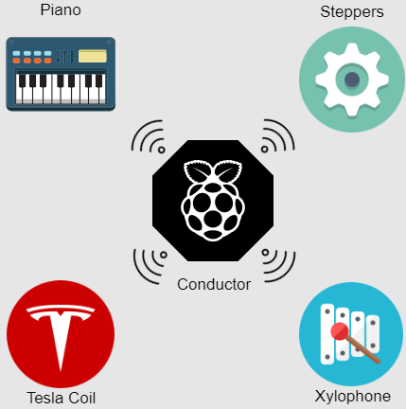

Figure 3.1: Conductor with four instruments

### SDManager

SDManager, is the name given to a collection of Python scripts used to prepare the orchestra to play a track. Initially the user selects a song in a MIDI format and edits it using Anvil Studio to remove/add/modify channels of the track. However, MIDI files are too complex for a microcontroller to work with, and too tedious for the team to work with, so a script called *MIDI2Text* was written which takes as an input a MIDI file, parses it and returns to the user a stripped-out version of the MIDI file with only the core information needed for the orchestra to recreate the track accurately. The information returned are three arrays: a time array; with the timing information, a note array containing the note to play/release and finally a status array which tells the instrument weather to play a note or release it. The script also handles other things such as converting the time from ticks (MIDI notation for time) to seconds and was also used in the development of the instruments as it can return data to the developer such as the number/notes each track uses. Furthermore, the script can separate the MIDI file into separate channels which correspond to each instrument so only the portion of the MIDI file which corresponds to the selected instrument in extracted. MIDI2Text is crucial to the development of the instruments as it saved the team a substantial amount of time and effort which would otherwise had to be put in converting the MIDI file manually.

The team chose to use SD cards to store the various tracks on the microcontrollers since they are a cheap non-volatile memory solution. Another script was developed which takes the output of *MIDI2Text* and transfers it onto the SD card in either a text format or a binary format (depending on how the instrument interprets the data). The script creates a folder with the name of the song, as well as four subfolders, on containing the timing file, note file, status file and one containing some metadata required by the instrument. Although most instruments use the binary format, the text-based format is used in the xylophone and is also useful when checking that the data written is correct. Additionally, another script was developed to allow the user to easily check the contents of the SD card and delete any tracks directly through SDManager.

Once these pieces of software were developed and tested they were merged together, so the user needs to follow five simple steps to take an edited MIDI file and save the portion of the MIDI file required by the instrument onto an SD card in .bin or .txt format for the instrument to play. These steps are:

1. Select path to SD card.
2. Select path to MIDI file.
3. Select .bin or .txt format.
4. Select name to save as.
5. Select instrument.

|  |  |
| --- | --- |
| **Name** | **Description** |
| **MIDI2Text** | Converts a MIDI file into either a text file or a binary file  containing the three arrays needed by the instruments. |
| **SDManager** | Saves the output of MIDI2Text for into an SD card. |
| **bitHoven** | Handles the communication between the Raspberry Pi and the instruments. Used to PLAY and STOP a track. |

Table 6: Summary of scripts

### Bithoven

The second collection of scripts are used when playing music on the orchestra. The team opted to exploit the wireless capabilities of the Raspberry Pi to create a network of instruments with the conductor acting as a central server. This removes any wiring between the conductor and the instruments resulting in a more professional and refined product. It also given the project an Industry 4.0 feel, something which has been of great interest lately. The conductor can then transmit commands to the instruments wirelessly and fulfils the requirement of synchronising the instruments.

### Wireless Network

The RPi has been configured as an access point for the instruments to connect to, this removes the need for an external WIFI network, which might not always be available or secure. Messages in the MQTT protocol contain ‘topics’ which nodes can subscribe to. A node can publish to any topic and any other nodes subscribed to the topic will receive the messages. In more detail, the RPi runs the MQTT ‘Broker’**,** all messages which are published go through the broker, which sorts them and retransmits them to each node which has subscribed to the topic of the message. Each instrument has a topic associated with it and is subscribed to that, furthermore all instruments are subscribed to a BROADCAST topic. The conductor itself is also a node within the RPi; it is subscribed to all the instruments and the broadcast topic and can transmit commands to each instrument individually or to all instruments simultaneously. The IP address of the RPi has been configured as a static IP and the instruments are programmed to connect to that specific IP once they are powered on, allowing them to receive and transmit messages to the RPi.

The conductor can then publish one of three commands to the instruments. A PLAY command followed by a song name causes the receiving instrument to download the song from the SD card and play it once it receives a START condition from the conductor. A STOP command from the conductor cause the instrument to halt any song that is currently playing, this allows the user to play another song or simply stop the song. Finally, a LISTtracks command causes the instrument to read the tracks stored in the SD card and returns them to the RPi, this allows the user to see which songs have been saved without having to remove the SD card and putting it in a computer. Since all the configuration for the MQTT protocol has already implemented, adding additional features mean they only need to be implemented on the microcontroller, allowing the developer to expand the functionality without prior knowledge of the protocol.

### Summary

In summary, the conductor contains various scripts to handle any interaction the user might need with the orchestra. It allows the user to easily convert MIDI files and load them onto an SD card without any knowledge of the MIDI protocol, and in a format which is easily read by any microcontroller and computer. Since the conductor was designed with the intention to add additional instruments to the orchestra it can also be very useful for developers to obtain various information about the songs their instrument will need to play. A graphical user interface (GUI) was developed to run on the RPi with the goal of simplicity in mind. The GUI in combination with a touchscreen connected to the Pi allows the user to have a fluid experience with the orchestra.

## Instrument Software Overview

The software for the instruments was written in two programming languages, the Tesla, Steppers and Keyboard instruments were written in C++ and the Xylophone was written in LabView. However, regardless of the programming language all instruments follow the same structure. This was done deliberately in order to allow the team to manage the software for the various instruments and make debugging and maintaining the code easier. The Tesla, Steppers and Keyboard will utilise a Teensy 3.5. Initially they were going to use Arduino Unos, however, it was found that the arrays needed for the songs would be too large for the flash memory on the Arduino. For example, the files needed for *Californication* amounted to 84 kB whereas the Arduino only has 32 kB flash memory. The Arduino was replaced with a Teensy 3.5 which has 512 kB, enough to store the files for either of the songs needed for the demonstration.

### Initial setup

When first powered on the instruments execute a setup() function, which executes code (e.g. setting IO pins to be either output or input) to get each of the instruments ready to play notes. Once the setup is finished the program enters a loop() waiting for instructions. The main loop was designed to resemble a finite state machine (FSM) with two states, a PLAY state and a listTrack state. **The** program enters a specific state in the finite state machine once it receives a specific command from the conductor. The next section will explain how the WiFi module receives commands from the conductor.

### WiFi module

The WiFi module allows the user to communicate wirelessly with the instruments thereby removing the need for wires. This has two effects: firstly, it gives the orchestra a more refined look making it more appealing to the public and secondly, it adds Internet of Things (IoT) capabilities to the instrument which is something of great interest in the technology sector and is likely to attract more attention. Since the module can be programmed separately and acts as a standalone system it can be used in conjunction with any microcontroller which supports UART. For this reason, the WiFi module is used on all instruments including the ones with processors which already support WiFi. This was done deliberately to save time as the code as well as hardware needs to be developed only once.

The ESP-8266 is a low cost WiFi chip with a full TCP/IP stack with microcontroller capabilities. Although many versions exist, the exact module used in this project is the ESP-01. This module was selected due to its small package size and relatively low cost. The smaller size allowed it to be integrated with any of the instruments. The software for the WiFi module was written in C++ using third party libraries.

Due to the small package of the of the WiFi module, only eight pins are available. Out of those, two are reserved for serial communication (Rx and Tx), two are GPIOs (general-purpose input/output) and the rest are used for programming. When the module is first powered on it automatically connects to the WiFi of the Raspberry Pi and subscribes to a unique topic for each instrument. Once a message arrives from the conductor to the WiFi module it then passes that message to the microcontroller of that instrument via UART (Tx and Rx). Once the WiFi module is ready to transmit via serial one of its GPIO pins goes high which triggers an interrupt in the microcontroller to read the serial buffer. The instrument is also capable of transmitting messages back to the conductor which is useful for debugging purposes as well as transmitting information such as the songs stored in the instrument. If at any point the connection between the WiFi module and the conductor is broken the module will automatically attempt to reconnect. The user can send a PLAY command followed by the track to be played, a STOP command or a listTrack command. The next section explains what happens when these commands are sent to the microcontroller.

### playTrack

A PLAY command followed by the track to be played causes the program to enter a function called playTrack(track) which takes the track name to be played as an argument. This function initially gets the sizes of the time, note and status arrays needed to play the track. It then downloads the data from the SD card and stores them locally on the microcontroller and enters a while loop, where it waits for the conductor to transmit a START signal (which it does three seconds after the PLAY command is sent). Once the start signal is received, the track starts playing in the following way.

### Playing a track

A key idea when developing the code was reliability when playing a track. The largest cause for causing the song to sound distorted is playing the notes at the wrong timings. Any delay in the code during a track playing could potentially have that effect. To try and prevent this, timer interrupts were used to ensure that notes are played at the exact times as specified in the MIDI file. An *Interrupt Service Routine* (ISR) triggers at the exact time a note is due to be turned on or off and performs that action. It then updates the timer interrupt with the next value from the time array.

The ISR for each instrument varies depending on how the instruments play notes and is described in the software section of each instrument. A while loop is used in order to stop the program from continuing while the track is being played. When the track has finished, or a STOP signal is received, the program exits from the while loop and performs any tasks necessary to setup the instrument to play another track. Finally, it enters the main loop()awaiting further instruction from the user.

### listTrack

The listTracks()function reads the contents of the SD card, transmits it to the WiFi module via USART which then transmits it back to the user via WiFi.

## Keyboard

The following sections will first summarise the main components of the keyboard and then describe the design decisions made in the design. To meet the aims of the project, the keyboard needs to meet the following specification:

* play the tracks chosen for the keyboard from the three selected pieces of music. (objective ?). the main steps to doing this are
  + select a keyboard
  + design and manufacture PCBs to power solenoids
  + design and build a stand to hold the Solenoids and PCBs
  + select a microcontroller
  + write software for the microcontroller to control the instrument
  + integrate the software with the hardware
  + test that the keyboard can play all the required notes for the three chosen songs
* communicate with the conductor so it can be controlled alongside the other instruments (objective 4)
  + write software so the instrument can be controlled remotely with the conductor
  + integrate the Wifi module with the Teensy
  + integrate the conductor with the instrument
* be transportable (objective 3)
  + design the hardware so it can be dismantled to be placed in a box for transport. design the hardware so it can be dismantled to be placed in a box for transport.

### Overall design description

Figure 3.3 shows the keyboard design with closer views shown in Figure 3.4a and Figure 3.4b. The robot keyboard design uses solenoids to press the keys and a Teensy microcontroller board to control the instrument. The solenoids are supported by a Bosch bar and are connected to the Bosch bar using threaded rods, which are split into two different lengths: 60mm and 105mm for the white and black keys respectively. The solenoids attach to the threaded rod using a bracket made from clear Perspex, allowing the solenoid to be positioned at any point along the rod and allow it to be adjusted vertically by 25mm. The Bosch bar has a threaded rod at each end to support it, so its position above the keyboard is adjustable. The PCBs to control the solenoids are mounted on a Perspex plate that is attached to the Bosch bar. There are 25 solenoids set up which cover the notes required for the three chosen test tracks (Appendix 7.4)This decision was made to keep within the project budget. The instrument has been designed so that in the future more solenoids to cover the full range of notes can be easily added. In addition to this, the Teensy 3.5 [43] is connected to eight SN74HC595N shift registers [41] which allowed the software to be designed with the ability to expand in mind. The solenoids set up could also be easily moved to play other notes if necessary. The instrument can be dismantled; the threaded rods unscrewed from the Bosch bar and the base plates meaning it can be transported in a … box(need to put it in a box to test).

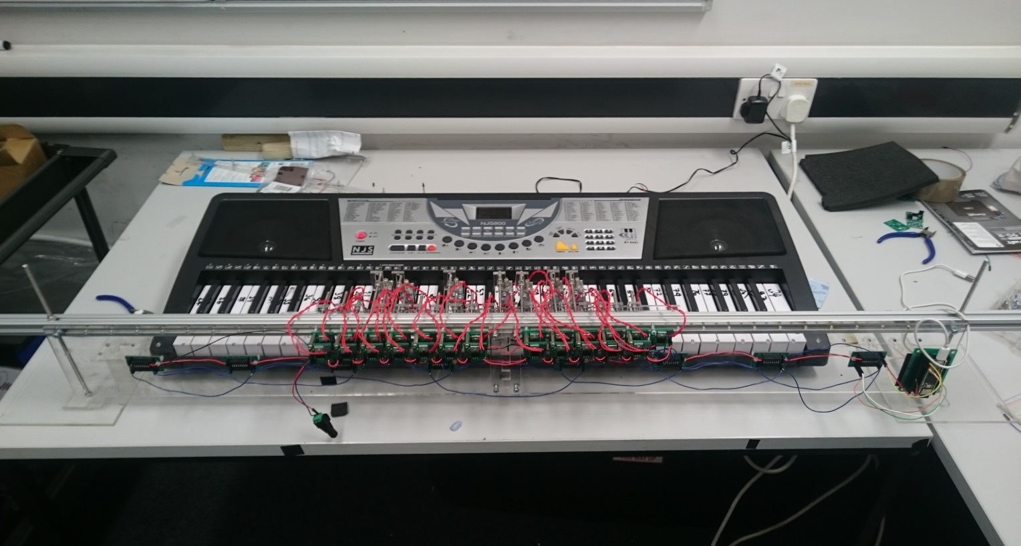

Threaded rod supports with base plate

Shift register PCB

Solenoid switching Transistor PCB

Solenoids and brackets

Bosch Bar

Teensy Embedded system

Figure 3.2 Keyboard hardware overview

|  |  |
| --- | --- |
| C:\Users\Josh\AppData\Local\Temp\DSC_0109.JPG  Solenoid  Bracket  Threaded rod  Figure 3.3 (a) Close up view of  solenoid set-up | C:\Users\Josh\AppData\Local\Temp\DSC_0110.JPG  Solenoid transistor PCB  Shift register PCB  (b) Close up view of PCB mount |

### Solenoid Selection

The solenoids that would be used to press the keys needed to be selected. Firstly, a test was carried out to find the force needed to cause the keys to play a note. A description of the test along with the results table is given in Appendix 7.5. A mass of 70g is required to press down a key, so using a safety factor of 25% extra mass, the force need to press the keys can be calculated using equation (1).

F = ma (1)

where F is the force due to gravity (N), a is the acceleration due to gravity 9.81m/ $s^{2}$ and m is the mass (kg). This gives a force of 1.03 N or 105 gf(gram force) needed to press the keys. The distance the key needs to be depressed is 3mm before a sound is made, so allowing a 25% safety factor the solenoid throw needs to be at least 3.75mm. In the music chosen up to 4 keys need to be played at the same time, so the solenoids also need a low current demand, so they can be powered using an off-the-shelf power supply. The 12V 3W SD0630 fulfils these requirements as it can provide 120gf with a duty cycle of 50% (none of the songs require any one note to be depressed 50% of the time (section 4.3 of the interim report calculates the maximum to be 30%). It also has a throw of 10mm. It has a current requirement of 0.25A so 8 could be pressed at once using a 12V 2A supply (solenoid datasheet in Appendix **Error! Reference source not found.**).

Initially, one solenoid was bought to test. The solenoid came without a stopper which should prevent the plunger coming out of the solenoid. So, stoppers were laser cut in the mechanical workshop these stoppers can be moved along the plunger which allows the solenoid throw to be adjusted. The solenoid was tested, and it was able to press both the white and black keys.

The main issue found when testing the solenoid was the clicking made when the solenoid switches on and off. This was partially solved by putting foam between the stopper and the solenoid as shown in Figure 3.5. Section can be removed if struggling for space[This lessened the effect however; another clicking sound was made when the plunger hit the inside of the solenoid. An attempt was made to lessen this as well by putting a small piece of foam on the plunger Figure 3.5. This caused issues to the working of the solenoid as it added extra resistance for the solenoid to work against. Therefore, it re-acted slower when turning on and caused different delays between each solenoid. It was decided this would cause issues with playing the songs and the synchronisation of the instruments so the foam on the plunger was removed]. The volume of the keyboard can be turned up to a level that mitigates the sound of the clicking. The clicking is not entirely a negative as it gives the instrument a mechanical sound which fits in with the aesthetic of the orchestra.

|  |  |
| --- | --- |
| C:\Users\Josh\Downloads\DSC_0092.JPG | C:\Users\Josh\Downloads\DSC_0095.JPG  Stopper  Stopper Foam  Plunger Foam  Plunger |
| Figure 3.4: Solenoid with foam | |

### Supporting the Solenoids

To make the assembly of the rail supporting the solenoids functionally flexible a Bosch bar was used as it allows the solenoids to be placed at any point along its length. This is achieved using T-slot nuts to secure the threaded rod in the Bosch bar to which the solenoids can be attached. The threaded rods will be 4mm in diameter as the T-slot nuts are M4.The assembly is shown in Figure 3.6.

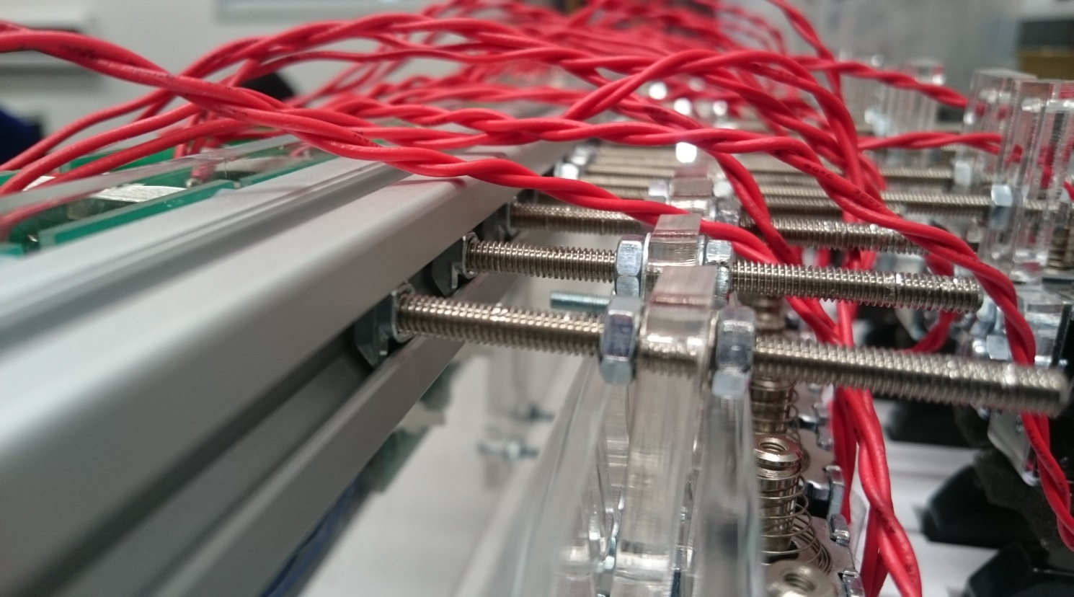

T-slot nut

Threaded rod

Bracket

solenoid

Bosch Bar

Figure 3.5: Close view of Bosch bar structure.

A bracket was required to connect the solenoid to the threaded rod. This needed to be easily adjustable, so the solenoid could be put into a position from which the keys are played when the solenoid is activated. It also had to be limited in width as the keyboard is 726mm long with 36 white keys which leaves 20.16mm per key for the bracket. However, space for a 4mm rod also has to be left for rods to pass through to the black keys leaving 16mm. The width of the solenoids is 15mm meaning that the bracket must be the same width as the solenoid.

The design went through several iterations. The first design is shown in Figure 3.7a it allows for vertical movement but not movement along the length of the threaded rods therefore, the rods would have to be made to the exact length and it would not be adjustable. The next design is in Figure 3.7b this allows for horizontal and 25mm of vertical movement, the design is stepped so the threaded rod for the black keys can pass the solenoid plunger. It also means that the part of the bracket that will connect to the solenoid can be greater than 16mm wide as the threaded rod for the black keys will run past the upper section of the bracket. The third design just adjusted the distance between the step so there was a 1.5mm difference between each side which makes it easier to overlap them in the mounting process Figure 3.7c.

|  |  |  |
| --- | --- | --- |
| Figure 3.6 (a) 1st design | (b) 2nd iteration | (c) 3rd iteration |

### Solenoid PCB design

The solenoids are controlled by the Teensy via the use of shift registers so multiple notes can be sent to the keyboard at the same time. The solenoids require a 12V supply, but the shift registers use the teensy’s 3.3V supply, so a transistor is needed to switch the power supply to the solenoids on and off. The required current for each of the solenoids is 0.25A. The Teensy can provide 250mA with its 3.3V power rail, the maximum number of keys pressed at once in the chosen music is 4 solenoids playing at the same time, which would split the output current of the teensy into a possible 62.5mA per transistor. The solenoids require 025A this means that a separate power supply will be require to power the solenoid and a transistor will be required to switch solenoids on. The DC current gain required for the transistor is 0.25/0.06=4.

It was decided to use the same transistor that will be used for the xylophone solenoids so that only one type of transistor needs to be ordered and the same circuit and PCB could be used for both. The gain needed for the xylophone transistor circuit is 13.3 (as shown in section ?). The decision was made to use the BJT TIP120 [reference to the data sheets] which can handle 60V 8A and can provide a gain of 1000 when Ic=0.25A. The equation for calculating RB is:

RB = (VIN – VBE) /IC / HFE  (2)

Where RB is the resistor value required at the base of the transistor (Ω), Vin =3.3V is the input voltage to the transistor (V), VBE =1.5 V is the base emitter voltage of the transistor (V), IC = 0.25 A is the collector current (A) and HFE = 1000 is the DC current gain of the transistor*.* This gives a value of RB = 7.2 kΩ. Therefore, a value from the E24 resistor series of 6.8 kΩ was chosen as this will provide a lager base current so will meet the collector current requirement.

### Supporting the Bosch Bar

It was decided to support the Bosch bar using two 5mm threaded rods, one located at either end of the bar as shown in Figure 3.3. This allows the height of the solenoid rail to be adjusted. The length of threaded rods were set at 230mm long as this allows for a key height of 70mm, the 20mm thickness of the Bosch bar, 80mm for the solenoid and leaving 70mm to allow the rail to be moved upwards and remain supported while, the keyboard is removed from under the solenoid rail.

A stand plate is needed to hold the threaded rods attached to the Bosch bar vertically upwards. It was decided to use clear Perspex for the various brackets and supporting plates for the instrument. The design is shown in Figure 3.8 two Perspex pieces , the base plate allows the lower nut to be counter sunk so it is flush with the surface the stand is placed. The top plate is glued to the bottom plate and is attached to the threaded rod using two nuts which clamp the rod to the plate. An M5 nut is 3.5mm thick and 9mm wide so to make sure the nut is flush with the base the Perspex needed to be thicker than 3.5mm and the hole needs to be at least 10mm wide. The laser cutter in the workshop can only cut Perspex with a maximum thickness of 1cm. It was decided to buy a 5mm thick, 600mm by 600mm sheet of Perspex from the workshop for £40 which could be also used for the other Perspex laser cutting needed for the rest of the instruments.

Threaded Rod

Nut

Top plate

Base plate

*Figure 3.7: Sketch of the keyboard stand to support the threaded rods either side of the keyboard*

With the two stands at either end of the keyboard there is a possibility the stands will be knocked and move the solenoids out of position from above the correct keys. A Perspex bar was designed to connect the two stands together. There is a channel running the length of the underside of the keyboard in which a bar can be run to connect the two Perspex stands together. The design is shown in Figure 3.8 diagrams can be found in Appendix 7.6.

Top plate (Perspex)

Base plate (Perspex)

Threaded Rod

Joining plate between stand and connecting bar (glued)

Joint between the two sections of the connecting bar

Joining plate glued between the two sections of the connecting bar

Keyboard

Solenoid rail

Top view

Side view

Figure 3.8 Sketch of connecting bar between the two stands (not to scale)

A picture of the bar connecting the two stands can be seen in Figure 3.10. Initially the stand and the bar were connected using a screw and nut (the locations can be seen in Figure 3.10) however, this method was found to loosen over time, so a plate was glued overlapping the two sections. Two stopper pieces of Perspex were made to stop the keyboard sliding along the bar the design is shown in Figure 3.10Figure 3.10. This means the solenoid rail is held in the same position by the keyboard and cannot be moved forwards, backwards or sideways.

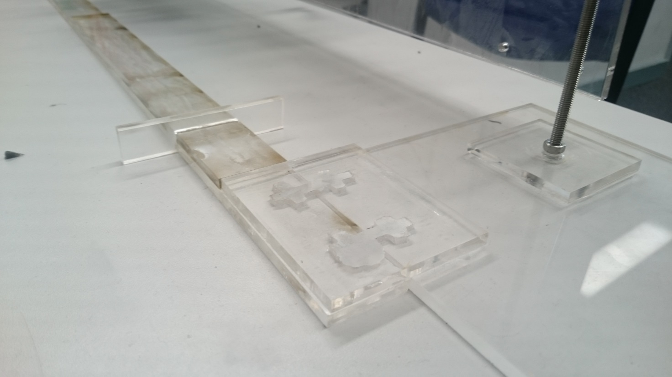

Threaded Rod

Connecting Bar

Keyboard stopper

Stand and connection bar attachment plate

Previous screw connection points

Figure 3.9: Stand and bar connection

### PCB Support Plate

The instrument has 8 shift registers PCBs, 25 transistor PCBs and 1 Teensy PCB, to display the PCBs it was decided to mount them on a Perspex plate which was mounted on the Bosch bar as shown in Figure 3.11. The keyboard instrument is designed is so that it can be expanded to have solenoids for all of the keys, so space has been left on the plate for more transistor PCBs. The size limits of the plate were set at 1100 mm long and 120 mm wide, so it would fit neatly along the front of the keyboard.

The transistor PCBs were mounted along the top to make wiring up the solenoids easier, to fit all the PCBs on they had to be mounted as a double layer (shown in Figure 3.11). The shift register PCBs are mounted below the transistor PCBs. The design for the plate is in Appendix 7.6**.**

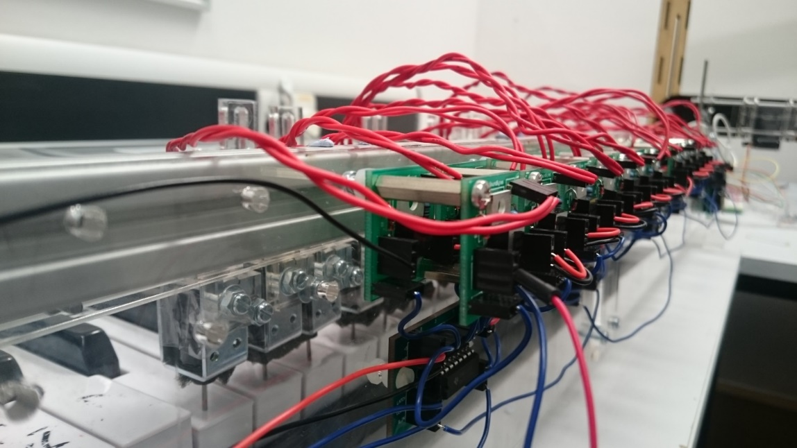

Figure 3.10: Transistor PCBs mounted on the Perspex plate

### Keyboard Software

As mentioned previously, the keyboard software was designed with the ability to expand in mind. The software will be designed so that songs containing more than just the 25 keys can be played without having to change the software, just adding the additional solenoids. As described in the previous section, each of the solenoids are connected to a transistor circuit, where each transistor circuit is connected to the output of one of the shift registers.

To cover the full 61 notes available on the keyboard, eight shift registers will be needed. This means that, since each solenoid represents a specific key, they must be connected to specific pins on the chain of shift registers. The benefit of this is that it is simple to continuously add solenoids to the keyboard so that all the notes are available to play without making any change in the software. The shift registers will be represented by a 64-bit variable in the software, where each bit of the variable represents a specific solenoid and note. For example, bit 0 of the of the 64-bit variable represents the lowest note on the keyboard, which is the MIDI note 24.

The latch feature will be very useful when the keyboard must play a chord (multiple notes played at the same time) as it means the solenoids will be pressed down at the same time. If the commands for each note in the chord were sent sequentially then it would not sound like chord, but a series of notes played quickly after each other.

### Structure of the program

To test the shift registers, a circuit consisting of 16 LEDs and two shift registers was constructed. The cathode of each of the LEDs was connected to ground and the anode of each LED was connected to a pin on one of the shift registers. From the testing it was found that, even though there were two shift registers connected in series (providing 16 output pins) it was only possible to write an 8-bit variable to the registers. This means that to write a 16-bit variable and display them on the shift registers, it would have to be split in to two 8-bit variables which will have to be written to the shift registers one after another. So, for use on the keyboard eight 8-bit variables would need to be written to the shift registers to cover the full 61 keys, meaning that the shiftout() function (the function that writes to the shift registers) would need to be called eight times. This means that more instructions will have to be executed, which needs to be taken into consideration when synchronising different instruments together.

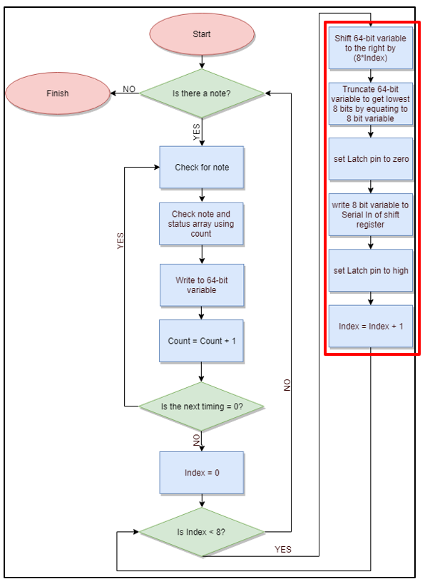

Figure 3.11 Structure of keyboard software that occurs within an Interrupt

Figure 3.11 shows the structure of the software for the keyboard. Once the program has started the *Count* variable is used to check whether there is a note available in the note array found on the SD card of the Teensy. Since the lowest MIDI note supported by the keyboard is 24 and the 64-bit variable starts at bit 0, then 24 needs to be subtracted from the note number obtained from the note array to get a corresponding bit number. For example, if note 54 needs to be played then this corresponds to bit 30 of the 64-bit variable. Once the note number has been achieved the *Count* variable is used again to determine the status of this note from the status array. Using the note and its corresponding status, the 64-bit variable can be updated to represent the current status of the song.

To update the 64-bit variable, the bitWrite() [44] function found in the Arduino library is used. The bitWrite() function takes three variables, the variable which will have its bit changed, the number of the bit to change and the status to be written to that bit. Each of these parameters is represented by a 32-bit variable, but the keyboard uses a 64-bit variable, so the functions had to be redefined in order to make them work with a 64-bit variable. This was done by redefining the bitWrite() function so that it works with an unsigned long long variable as opposed to just an unsigned long variable. This makes it so that the bitWrite function can now accept and modify a 64-bit variable.

Once the 64-bit variable has been modified the next stage of the program checks whether there is another change to the notes at this particular time. As the software is controlling a keyboard, a possible of 16 changes are possible at any one time (8 notes turning off, 8 turning on). A simultaneous change can be detected by checking whether the next element in the timing array is a zero. If it is a zero, it means that the change in note is happening with the previous change in notes before progressing. To detect whether these changes are happening at once the program enters a while loop, this increments the *Count* variable and checks the corresponding element in the time array to see whether it is zero. If it is a zero, it updates the 64-bit variable using the bitWrite() function. Once the loop is complete (i.e. when the program detects that the next element in the time array is non-zero), the program updates the interrupt timer to the value of the next non-zero element in the time array.

Once the next non-zero element is found in the time array this indicates that all the changes to the notes have been for this particular time in the song. The next stage is to take the 64-bit variable, break it into eight 8 variables and write these to the shift register. This is done by first setting the latch pin (pin 12) of the shift register and *Index* variable to zero and then entering a for loop. Within the for loop (shown in red on Figure 3.11) the 64-bit variable is shifted by (8\**Index*) and is truncated by equating it to an 8-bit variable. This truncated version is then written to the *Serial In* (pin 14) of the shift register. This is repeated eight times, each time incrementing the *Index* variable by one. In this way, the entire 64-bit variable is written to the shift registers 8 bits at a time. Once this is complete, the latch pin is set high, which outputs the bits on the shift registers to the solenoids. Since it does this in parallel all the changes at that particular instant in the song are made at once. Once the latch pin is driven high, the program waits for the start of the next interrupt and starts again.

### Keyboard Testing

To test whether the keyboard hardware and software had been built and constructed correctly several tests were run. The first test involved creating a program where the user could specify a specific key and get that single key to press down on the keyboard. This was a way of testing whether each of the solenoids fixed to the Bosch bar can press down and producing a note on the keyboard. The test results showed that each of the solenoids can produce a note, the test results can be seen in Appendix 7.7.

In addition to this test, the *Game of Thrones* theme song was played on the keyboard and timed to see how long it would take to complete. This was compared with the MIDI file version to show in both cases the song completed playing after 1 minute and 24 seconds. Both of these tests combined showed that the keyboard, when being played on its own, was performing as expected.

### Keyboard summary

The keyboard software utilises a chain of eight shift registers, totalling 64 output pins to cover the 61 keys available on the keyboard. Each of the pins represents a single note of the keyboard. A while loop is used to modify the 64-bit variable to represent the current status of the song. Once this has been done, a for loop is used to break the 64-bit variable into eight 8-bit variables that are written to the shift registers one by one.

## Xylophone

The xylophone was chosen to demonstrate the workings of a full electronic system. To meet the aims of the project, the xylophone needs to meet the following specification:

* play the tracks chosen for the xylophone (objective 2)
  + design and manufacture PCBs to power solenoids
  + design and build a stand to hold the Solenoids and PCBs
  + write software for the MyRio microcontroller to control the instrument
  + integrate the software with the hardware
  + when each key is hit it must produce the corresponding note
* communicate with the conductor so it can be controlled alongside the other instruments (objective 4)
  + write software so it can be controlled with the conductor
  + integrate the Wifi module with the MyRio
  + integrate the conductor with the instrument
* be transportable (objective 3)
  + design the hardware so it can be dismantled for transport.

The xylophone is made from clear Perspex, so all the circuitry and processors are clearly displayed which increases the aesthetic appeal, making it more suited to exhibitions and demonstrations. As shown in Figure 3.12 the xylophone has a traditional shape with 12 keys. The keys are to be hit by solenoids which are held above the keys using a Bosch bar supported by two threaded rods. The xylophone can be disassembled so it can be transported easily. The Bosch bar can be removed, the keys can be taken off and the two sides of the xylophone can be taken apart. It utilises two systems, one uses a National Instruments MyRio that takes the sequence of notes to be played and actuates the solenoids to hit the keys; the second system also uses a MyRio and monitors 12 piezoelectric sensors mounted on the 12 bars. When one of the piezoelectric sensors is hit by a solenoid, the MyRio outputs the respective note through an amplifier to a speaker.

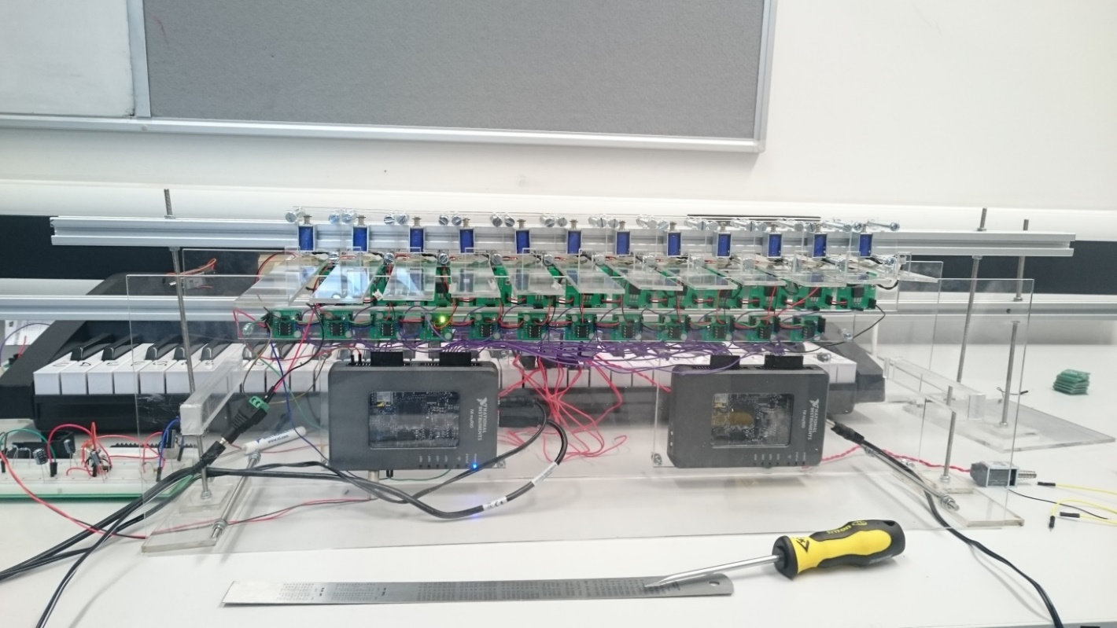

Figure 3.12: Xylophone instrument

### Solenoid choice and bracket design

The solenoids required for the xylophone have very basic requirements since piezos require a slight tap to produce a signal. The keys are 30mm across, so the solenoid needed to be smaller than this. As this are quite simple requirements and are independent of the force produced by the solenoid, the cheapest solenoid could be selected, costing £5 each. The dimensions are 10mm by 12mm and they have a power rating of 10W, (5V, 2A) which makes them more than capable of striking the piezo.

A bracket was designed to hold the solenoid onto the Bosch bar. Initially, a bracket was made by the workshop using a 3D printer, the issue with this bracket was that the socket holding the screw which held the solenoid in place would often come loose (shown in Figure 3.13). A new bracket was designed which was made from two clear Perspex plates that clamp the solenoids to the Bosch bar as can be seen in Figure 3.13. This design also fits better with the aesthetics of the xylophone as it displays the solenoid.

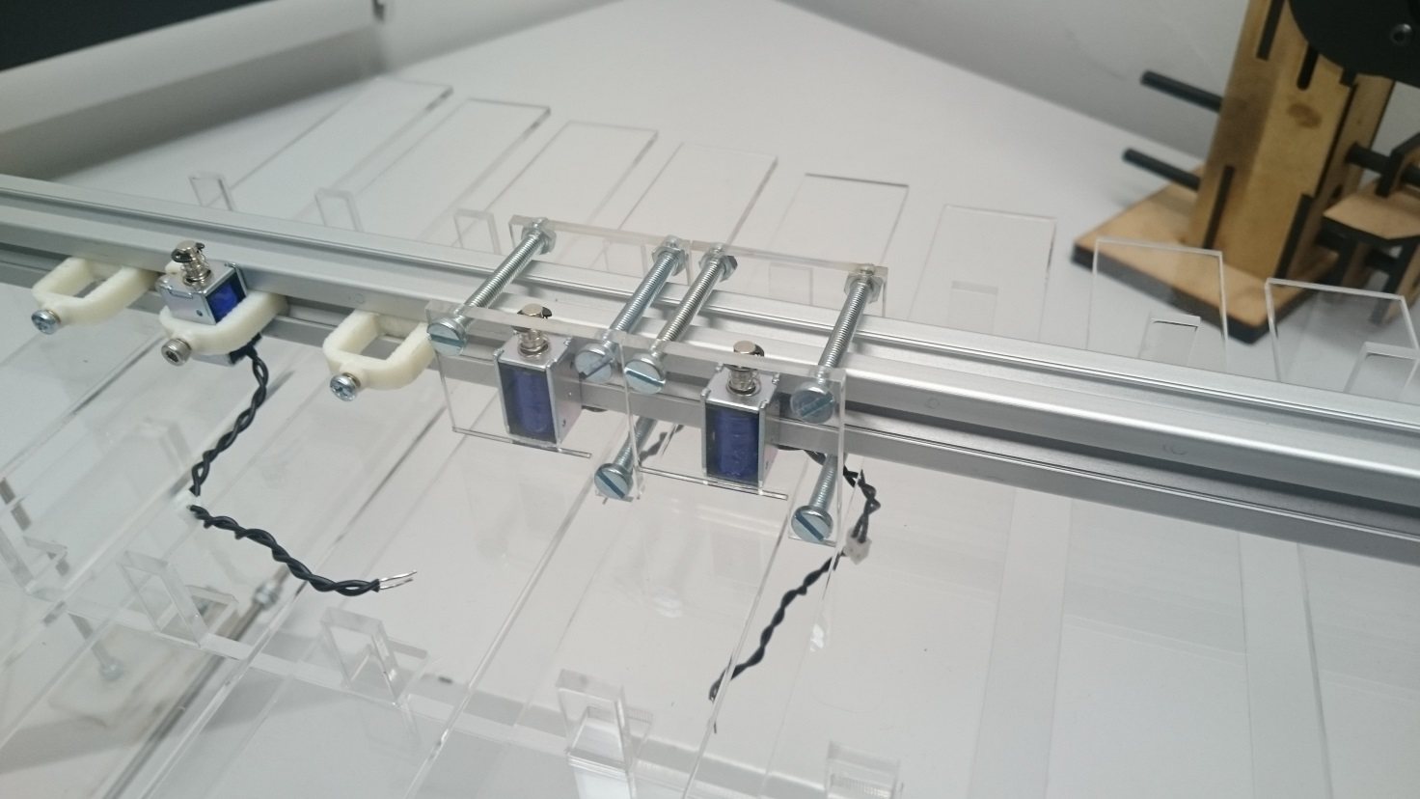

3d printed bracket

Socket that kept breaking

New bracket

Figure 3.13: 3D printed bracket and Perspex bracket

### Design of Bosch Bar Supports

The Bosch bar will be held using two M4 threaded rods which will be held vertically, using the same concept as used in the keyboard stands. The dimensions of the stands were adjusted so it could be attached to the xylophone. The dimensions for the bottom plate are 115x50mm and the smaller plate 40x30mm and it can be seen in Figure 3.14a. The bracket is attached to the xylophone using the connection shown in Figure 3.14b.

|  |  |
| --- | --- |
| Figure 3.14 (a) Stand for the Bosch bar | (b) Connection of the stand to the xylophone |

### Piezo Sensors

Piezo sensors were put on top of the xylophone keys to detect the solenoids hitting the keys. They were connected to a comparator circuit that compared the voltage from the piezo sensor and the reference voltage of the voltage divider at the non-inverting input. The output of the comparator circuit was connected to the MyRIO so whenever the output was high, the LabView program on the MyRIO played the corresponding note through a speaker. The MyRIO was the preferred microcontroller since it already had a built-in audio output.

|  |  |
| --- | --- |
| Figure 3.15 Piezo sensors on the keys connected to the comparator | Figure 3.16 LM311 Comparator PCB |

### Xylophone Transistor Circuit

A similar transistor circuit is used in the xylophone as was used in the keyboard. The VIN= 3.3 V, VBE = 1.6 V, gain = 4000 when IC = 2A. Therefore, the base resistor needed is, R = (3.3-1.6)/(2/4000) = 3.4 kΩ. Using the E24 resistor series a 3.3kΩ resistor was selected.

### Comparator circuit

After making the initial comparator circuit using a LM741 [45] and a voltage divider, several values of resistors were tested and it was found that a sensitive reference voltage was found to be around 0.2V that would detect the impact of the solenoid upon the piezo sensor. An LED was also placed at the output as an indicator. This circuit is seen in Figure 3.20.

R1 = 8000 Ohms and R2 = 330 Ohms.

$$Vref=V* \frac{R2}{R2+R1}=V*\frac{330}{330+8000} (1)$$

Where V is the supply voltage (5 V) there for $Vref=0.04*5=0.2 V$.

The circuit worked very similar to the final PCB and circuit design shown in Figure 3.19 and Figure 3.21, the only important difference being that the LM741 is powered by -15 and +5 volts whereas the LM311 can be powered by Ground and +5 volts. There were 12 of these circuit connected to each other and to the 12 xylophone keys and in turn connected to 12 individual inputs on the MyRIO.

After tests were done, there were problems with the piezo sensors when they were used for around 20 seconds, the LEDs indicated that the comparators stopped responding to the solenoid hits. This was fixed by adding a resistor in parallel with the piezo sensor to get rid of any build-up of static charge. Later it was noticed that there was -15 V at the output of the comparator when it was in the off state, which could damage the MyRIO, therefore the circuit was slightly modified, and a new comparator was added: LM311. This comparator could function of off ground as negative voltage supply so the danger of damaging the MyRIO was no longer there. The new circuit can be seen in Figure 3.21.

This leads to the LabView code that was used on the MyRIO to play the different sounds for each individual key.

|  |  |
| --- | --- |
| Figure 3.17 LM741 comparator circuit | Figure 3.18 LM311 comparator circuit |

### PCB Mounting Plate

To mount the different PCBs several Perspex plates were created. One for all of the comparator circuits, one for all the solenoid switching circuits and one for each MyRio. Having individual plates made the xylophone easier to disassemble and transport. The designs are in Appendix 7.8.

### Xylophone Software for Solenoids

The concept of the xylophone software, is to have three text files from each song, generated by the conductor to determine the current status of the song. The first text file contains the notes that need to be played for a specific song, the second text file determines the time delays between the notes that are being played and the final text file, defines the state of the solenoid; either on or off.

To begin with, the three text files for each song, which are generated by the conductor, are saved in a file directory within the MyRIO.

As explained in Section 3.1, the WIFI module sends a number of different commands (“PLAY”, “STOP”), along with the song that needs to be played. In order to make these commands interact with the xylophone, the WiFi module is connected to the UART of the MyRio.The UART (Universal Asynchronous Receiver/ Transmitter) is a piece of computer hardware (a microchip) which translates data between parallel and serial forms [46] [47]. It is mainly used for serial communications that contain a receiver and a transmitter; each clocked differently [48].

Focusing on the program structure, a flat sequence is used which has two frames. A flat sequence is used to ensure that a sub-diagram/frame executes before or after a sub-diagram/ frame. The first frame contains the interrupt which may occur while running the program and the second frame encloses the main program. The interrupt (in the first frame) is connected directly to the UART of the MyRIO, so when the UART reads a command, the interrupt is triggered. The are two commands sent by the WiFi module: “STOP” and “PLAY”, with the “PLAY” command being followed by the name of the song to be played, for instance “PLAYGoT” if the Game of Thrones theme song is selected. To make the UART interact with the rest of the program, two global variables are used; the first one contains the action that needs to be performed by the xylophone, i.e. “PLAY” or “STOP”, and the second one has the song which has been selected to be played.

In the second frame, a while loop is created which repeatedly executes the main program. This while loop is fed from the first global variable which contains the action, and therefore either stops or plays the specified track. Inside the while loop, a case structure exists which acts according to the action command read by the UART. If the command is “STOP”, then there are no text files loaded in the program and the program stops executing. On the other hand, if the command is “PLAY”, then the second global variable comes to use and informs the program which song needs to be played. Then, the appropriate text files are loaded from the c file directory of the MyRIO and three arrays begin to form, as mentioned previously.

Since the xylophone only has 12 notes, the next step of the procedure is to minimise the number of notes used in the songs. In order to do so, a formula node is used, in which the preferred octave is selected and all the notes (from that octave) are used. For instance, the Game of Thrones theme song, which has 19 notes from three consecutive octaves (octave 2, 3 and 4), is configured so that all the notes are contained in one octave, so the xylophone can play it. The appropriate octave is selected either according to the most frequent notes that are being used within the song, or in the case of having three consecutive octaves, the middle one is selected to minimise the deviation from the original song. Finally, 12 digital output ports are used from the MyRIO to control the solenoids of the xylophone.

For that reason, a while loop is used, which runs as many times as the number of notes in each song. Inside the while loop, there is a case statement which reads the status text file and sets the solenoid on or off. If the status is 0, the digital output pins are not enabled and therefore the solenoids are turned off but if the status is 1, the pins are enabled and according to the note array, the appropriate solenoid turns on for an amount of time which is determined by the time array (Figure 3.22). The while loop will only terminate if one of the following two cases occur. The first one is when the number of iterations of the while loop exceeds the number of the notes in each song and the second, is when the UART reads the value “STOP”, where it forces the loop to stop executing and start again when the command send to the UART (from the WiFi module) is “PLAY”.

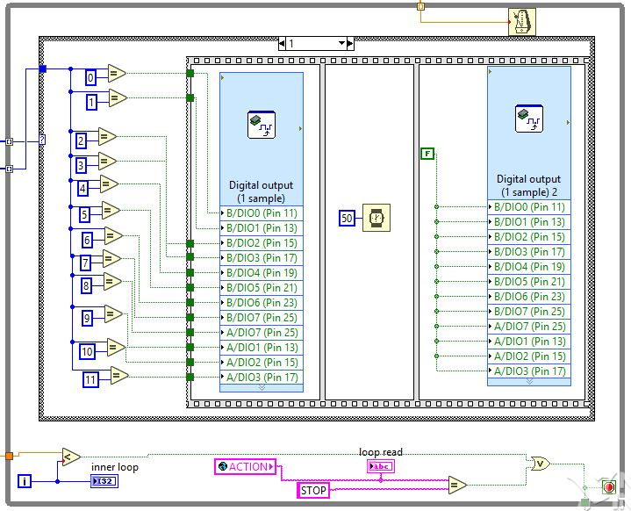

Figure 3.19: While loop which enables solenoids according to status

### Xylophone Software for Piezo Sensors

The code to play the different notes was made in LabView. The MyRIO cannot directly output a wav. or mp4 format files to the audio output therefore the wav. files of the xylophone notes, which were obtained from the University of Iowa Electronic Music Studios [49], were converted to a waveform and stored as the one-dimensional array, Y seen in Figure 3.23. This was all done offline since the MyRIO cannot do the converting in real-time [50].

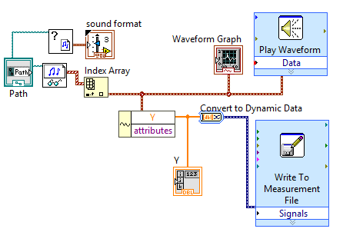

Figure 3.20 Converting wav. files to waveforms with help from [50].

This array was then converted to a constant and moved to the main program seen in Figure 3.24.

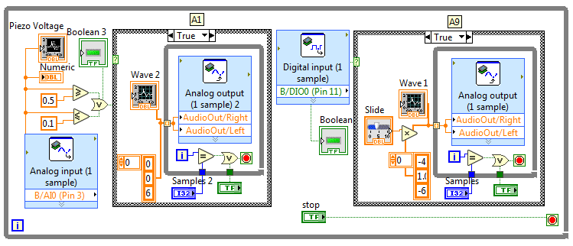

Figure 3.21 LabView code for analogue and digital piezo inputs

This code looked at the input from the pin to which the comparator was connected to and whenever it was high, it played the waveform from the 1D array through the audio output. The waveform was played at 44,400 samples a second, which was the speed that was specified when converting the sound files to an array, the number of samples played could be set to any number and the volume was changed by multiplying the amplitude of the waveform. The front panel (interface) for testing can be seen in Appendix 7.9**.**

This code was then expanded to 12 inputs and 12 waveforms for all the xylophone keys. The real-time module of the MyRIO was then used to store the code onboard and execute it every time the MyRIO was started up (Appendix 7.10).

### Speaker

A speaker which would play the xylophone notes was installed and an amplifier circuit connected it to the MyRIO output. This circuit allowed the user to tune the volume and gain of the speaker since it did not come with any inbuilt controls.

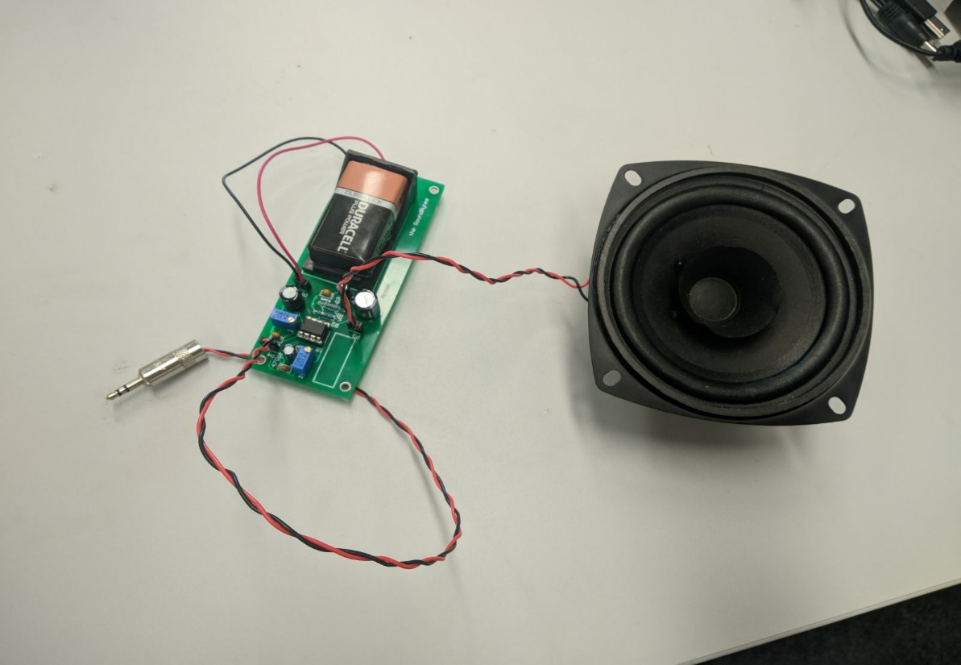

Figure 3.22 Visaton Speaker [51] connected to the amplifier circuit.

The datasheet [51] stated that the speaker was capable of outputting 86 dB between 80 Hz and 20 kHz frequencies, which was loud enough to play with the rest of the orchestra. To get to the higher sound levels, the signal from the MyRIO needed to be amplified.

An amplifier circuit was built following the instructions from [52]. This circuit allowed the user to control both volume and gain of the signal using potentiometers. This circuit can be seen below:

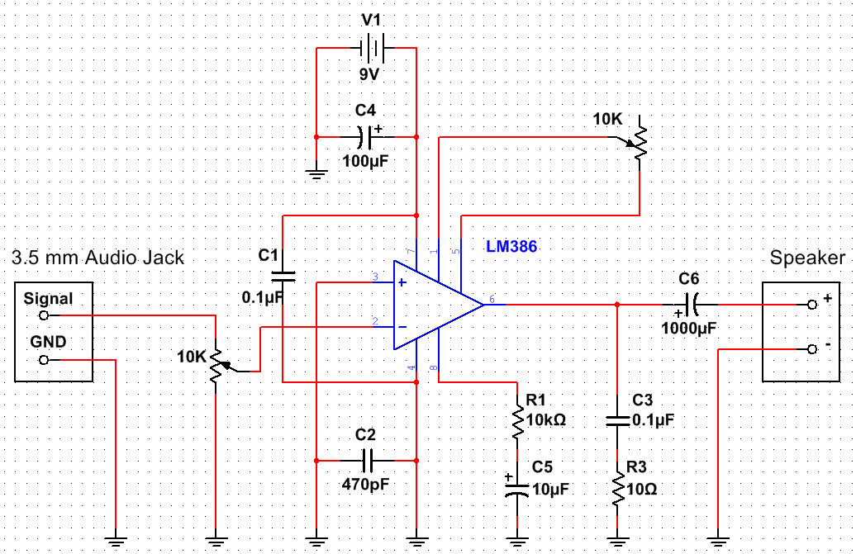

Figure 3.23 **.** Amplifier circuit with volume and gain controls based on [52].

This circuit used the LM386 chip for amplification. A 9 V battery was used as the power supply, but a MyRIO +15 V and ground could also be used as the LM386N-4 [53] chip can support up to 22 V as a power supply. The designed PCB can be found in Appendix 7.11.

This circuit was later used to amplify the microphone input for the Tesla coil setup, but it was later found out that the circuit could pick up the signal from the Tesla coil wirelessly, without a microphone.

### Xylophone Testing

In order to determine the functionality of the xylophone, several tests were performed, concerning both the hardware and software. More specifically, each solenoid was tested individually by writing a program where the user is able to choose which solenoid to be played. The purpose of this test is mainly to check the response of each solenoid (i.e. whether they turn on or off) and the ability of the Bosch bar (which hold the solenoids above the keys) to preserve its initial condition and not be affected by the impact of the solenoids.

To test the software of the xylophone, each song played by the instrument, was timed and compared with the MIDI file version. By doing so, the accuracy of the software was tested and since the two timings match (of the MIDI file and of the instrument), then it means that the xylophone behaves as expected.

For the piezo sensor testing, the first step was to test each comparator individually by connecting them to a MyRIO and running the code for only one note using code shown in Figure 3.21. After making sure all the circuits work and produce a note, the circuits were all mounted and all the twelve keys with the piezo sensors were attached to the xylophone. The testing for twelve notes showed that each key produced different note, going from low to high as the keys were hit from one end of the xylophone to the other.

### Summary

The xylophone has twelve solenoids that are controlled to the MyRIO. The MyRIO receives the commands through the wireless module which dictate which song to play. The keys have piezo sensors on them that are connected to another MyRIO using comparator circuits. The second MyRIO interprets the high input and plays the note corresponding to the key that is being hit. The sound is played through the speaker that is connected to the audio output of the MyRIO.

## Stepper Motors

The stepper motors were chosen as an instrument as they were able to play each musical note without requiring hardware modifications and as they offered a low-cost option for a musical instrument to be added to the orchestra. To meet the aims of the project, the xylophone needs to meet the following specifications

* play the tracks chosen for the stepper motors (objective 2)
  + design circuit for controlling stepper motors
  + write software for the microcontroller to control the instrument
  + test that the stepper motors can produce all the required notes for the chosen songs
  + design and build a mount to amplify the sound
  + integrate the software with the hardware
* communicate with the conductor so it can be controlled alongside the other instruments (objective 4)
  + write software so it can be controlled with the conductor
  + integrate the Wifi module with the Teensy
  + integrate the conductor with the instrument
* be transportable (objective 3)
  + design the hardware so it can be placed in a box for transport

### Stepper Motor Hardware

The stepper motor instrument is controlled by a Teensy 3.5 board. Similar to the keyboard, the instrument was initially designed to be used with an Arduino Uno but as the Arduino board did not have enough memory to store the data required for playing an entire song, the design was adapted for the more suitable Teensy board.

This microcontroller board was used to program a AD9837 Digital Synthesizer (DSS) IC [54] to generate the required frequency for each note to be played as the song progressed. The frequency generated by the DSS chip was then used together with a DRV8825 motor driver board [55] to control the rotation of the stepper motor. The DRV8825 was selected because of its high current rating of 2.5 A that matched the stepper motor current requirement of 1.5A [56]. Additionally, the driver board also had a current limiting potentiometer which allowed for each motor to be tuned individually so that each motor would produce a clear sound. To generate the musical notes, NEMA 17 stepper motors were used as they were rated at 12V and 1.5A [56] which allowed for easy interfacing with the DRV8825 motor driver board. Additionally, as the stepper motors are not loud when rotating, a wooden acoustic box was built for them to be mounted on so that the sound produced by the motors would be amplified and easier to hear in larger spaces such as those that are used for trade fairs and other expo events.

### Acoustic box

Due to the fact that the stepper motors do not produce loud sounds when rotating and as the instrument is likely to be played in crowded areas, a decision was made to amplify the sound produced by the motors by using an acoustic box. After testing the sound level produced at a test distance of 0.5 m with materials such as Perspex, wood and cardboard, the data presented in Table 7 has been obtained. As it can be observed, wood produced the highest sound amplification and as a result, the designed acoustic box was built using this material, acting similar to the acoustic box used by guitars to amplify the sound produced by the strings vibrations. The motors are held in place by using aluminium brackets fixed on the top side of the box so that the rotational movement of the shaft would not cause them to move out of position. The designed box is presented in Figure 3.24.

|  |  |  |  |  |  |  |  |  |  |
| --- | --- | --- | --- | --- | --- | --- | --- | --- | --- |
| |  |  | | --- | --- | | **Material Used** | **Measured Sound Level (dB)** | | Perspex | 48 | | Wood | 52 | | Cardboard | 46 |   Table 7 Sound Level measurements for different materials | Figure 3.24 Acoustic box built for stepper motors |

The acoustic box is designed to have attached to it a central PCB that contains all the components required for the operation of the stepper motor instrument: a single Teensy board, four DSS circuit boards, four motor driver boards and a WiFi module for connecting to the conductor. The design of the PCB is presented in Figure 3.25. The PCB that is to be mounted on the acoustic box was designed in a way that allows for each component to be easily replaced. This was done to minimise the impact on the overall performance of the instrument in the situation in which one component might fail and to also reduce the time it would take to fix the instrument in such a situation. Additionally, the slots on the PCB dedicated to the motor driver board are also compatible with other motor driver boards such as the Allegro A4988 which mitigates the risk of some components being difficult to source.

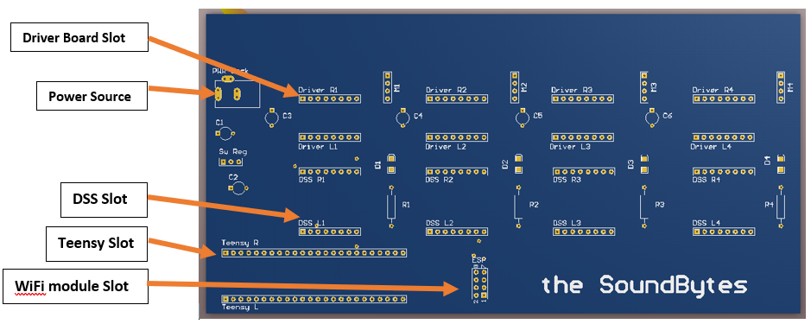

Figure 3.25Stepper Motor Instrument Central PCB

### Digital Signal Synthesizer

The selected Digital Signal Synthesizer (DSS) chip was the AD9837. This was due to its high accuracy, having a resolution of 0.02 Hz and being able to produce frequencies between 0-3 MHz [54]. As the frequencies in the audible range only go up to 20 kHz [57], the DSS chip was well suited for this application as it was able to produce the frequencies of all musical notes with high accuracy, meaning that the replicated songs sounded as close as possible to the original versions.

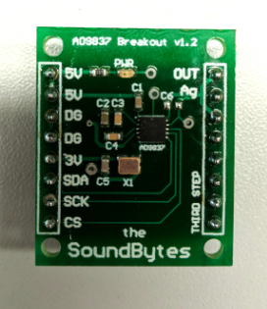

Figure 3.26Digital Signal Synthesizer PCB

Figure 3.26 presents the PCB designed for the DSS to be used with the other circuit units. As the IC was only available as a surface-mount component, particular care had to be paid when placing the components on the PCB.

### Motor Driver Board

In order to ensure that the stepper motors receive enough current, a motor driver board was used. For the stepper motor instrument, the selected model was the Texas Instruments DRV8825 [56]. This is because this model of driver board was recommended by multiple sources and according to [56], it was able to operate with voltages between 8.2V and 45V while supplying a current of up to 2.5 A, which was suitable for use with a NEMA 17 stepper motor. The schematic for the DRV8825 can be found in 7.13.

The STEP pin on the DRV8825 is used for controlling the movement of the motor. Each pulse sent to this pin is converted to a step rotation and the DIR pin is used for controlling the direction in which the motor spins. Additionally, a decoupling 100 µF capacitor has been used to protect the IC against voltage irregularities. In setting up the control circuit, the wiring diagram presented in [58] has been used for ensuring the wiring was done properly so as not to damage the components.

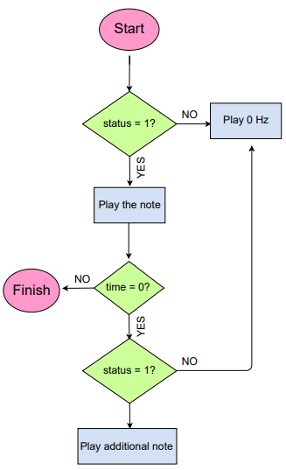

Figure 3.27 Flowchart of stepper motor software

### Stepper Motor Software

The stepper motor instrument relies on the SD card of the Teensy board to play a particular song.

The SD Card contains the arrays with the information required to play a song: note (contains the frequencies to be played), time (contains the time until the next action) and status (determines whether a note should be played or stopped). Figure 3.27 presents the code execution flowchart of the stepper motor instrument that occurs every time the ISR is executed. The note status has a value of either 0 or 1 which determines whether a note should be played (status is 1) or muted (status is 0). Additionally, a value of zero in the time array indicates that multiple actions have to be executed at the same time. The instrument’s code uses a function named “playnote” in order to play a specific musical note on a stepper motor. This function takes a frequency value as a parameter and encodes it onto the DSS chip which generated the corresponding signal which is further played by the stepper motor. By using this sequence with four stepper motors and four DSS ICs, the instrument can play up to four musical notes at the same time, thus increasing the number of songs that it can replicate.

### Stepper Motors Testing

The stepper motor instrument uses four stepper motors to play a song, meaning that it can support up to four musical notes being played at the same time. As the DSS chip can produce all the frequencies in the audible spectrum, the instrument is able to produce any musical notes that are required for a song, being a versatile instrument that can play both independently as well as in an orchestra, producing good replications of original songs.

## Decision on Fourth Instrument

The selection of the fourth instrument came down to either a tesla coil or panpipes. Both designs were considered and feasibility testing for each instrument was done with a deadline of the 14th of February set to make a final decision.

### Panpipes

There were three main designs for the panpipes throughout the project considered during the feasibility period.

|  |  |  |
| --- | --- | --- |
| Figure 3.28 (a) First design | (b) Second design | (c) Third design |

**First design**

The initial design seen in Figure 3.31 had the panpipes fixed to a base and the nozzle that directed the air from the pump (mattress pump at the time). The nozzle was on an elevated platform that would move from side to side to play different notes and had a stopper that would cut off the airflow when the platform would be moving from pipe to pipe. This platform would be powered by a stepper motor allowing it to move to individual pipes. This design was later changed to the second design shown in Figure 3.31b which would simplify the moving mechanism.

**Second design**

Instead of a stepper powered track moving sideways, this design involved mounting the nozzle onto a servo motor which could rotate 360 degrees. The pipes would also be taken apart and mounted in a circle around the servo with the nozzle. This design required very precise measurements regarding the angle of the nozzle (to make sure it was blowing air at the right angle over the panpipe) and the requirements of the stepper motor, since it needed to be able to rotate very quickly and accurately. Although this was possible, it was difficult to design this in such a way that it would be easy to transport as it did not easily dissemble and reassemble.

**Third design**

The final design seen in Figure 3.31c would have an air compressor providing the airflow since after tests were done it was established that the mattress pump did not provide enough pressure to produce a loud enough sound. There were to be 15 pipes coming from the compressor, providing airflow to each of the 15 panpipes. At the end of each airflow pipe there would be a solenoid valve that is normally closed, and when a specific note needs to be played, the valve would be turned on to let the air through. Plumbing fittings would be used to distribute the pressure and airflow between all the panpipes.

### Research and testing for the tesla coil

As mentioned in the literature review there are many examples of a tesla coil being used to play music, some producing streamers with lengths greater than 1 m. It was decided that building this type of tesla coil would not be feasible in this project. Firstly, the testing would have to take place in the High Voltage lab, which was undergoing improvement works, so the remaining test spaces were under demand and this would only leave a 3-week block to complete the testing when the hardware was complete. Secondly, the cost of building a larger one was a limiting factor as it was predicted to cost approximately £300 [59]. This estimate doesn’t include a switching circuit to play music and issues in development, adding a further 50% to account for these would increase the cost to £450 which is which is 30% of the budget. Finally, the other factor to take in to consideration is that the orchestra is to be taken to outreach days and having a high power tesla coil could be difficult to meet health and safety regulations. Due to these issues it was decided to buy three low power mini tesla coil kits available from amazon to test to develop a smaller Tesla coil.

The tesla coil kits included a circuit diagram with an explanation, however the description was in Chinese as can be seen from Appendix 7.14. Therefore, to progress with the tesla coil, the kits were tested to figure out how the circuit works, shown in Figure 3.34.



Figure 3.29 Circuit diagram for Tesla Coil

The circuit works as a high frequency oscillator where Q1 and Q2 switch on and off, which creates an approximate sinusoidal waveform shown in Figure 3.35 over the primary coil. This causes a voltage to be induced in the secondary which produces sparks/corona discharge at the open end of the secondary coil. When a music waveform is applied at V1 it modulates the power supply to the coil causing the switching waveform to be amplitude modulated.

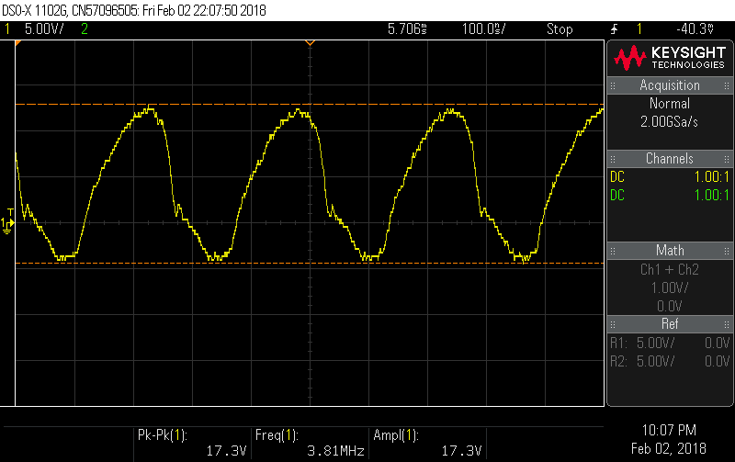

Figure 3.30 Single oscillation over the primary coil

As it can be seen the switching frequency is about 1/250x10-9 = 4 MHz and has a voltage range of +13 to -4V over the primary coil. As the turns ratio is 350 there will be a voltage ranging from 4550 to -1400V over the secondary.

The frequency of the audio wave form is about 1/75uS = 13 kHz this is as expected as it is in the audible frequency range, shown in Figure 3.36.

|  |  |
| --- | --- |
| primary coil  Figure 3.31 (a) Voltage waveform over the primary coil with no music playing | eye of tiger primary coil  (b) Voltage waveform over the primary coil with ‘eye of the tiger’ playing |

The maximum current in the primary coil is estimated to be 30 mA. As the base resistor, R4, is R4 = 10 KΩ and the voltage measured over R4 varies between 16 and 22V, the maximum current is 2.2 mA. The gain of the BD243C transistor is 100 so the collector current is 220 mA in the primary coil. In the secondary coil the current is 220 mA/350 = 0.6 mA. This is a very low current, so poses very little risk if someone was to come into contact with it.

The peak to peak voltage over the secondary coil is estimated to be about 6000 V, as the breakdown of air is 3 kV/mm, the length of the sparks were about 2mm long. As the spark from the secondary is so small, it is not going to cause any serious damage and can be controlled by putting the coil into a box, so it cannot be touched.

### **Issues found while testing**

One issue with the Tesla Coil kits brought from *Amazon* was that after continued use the heat sinks become hot and the volume produced by the coil reduced causing the spark to become a lot smaller. This is suspected to be due to the BJT heating up and so the losses increasing. The Amazon description does warn about using the tesla coil for more than 3 minutes.

The sound produced by the tesla coil is currently not that loud at only 55DB (measured using an Android app). This is about the same as conversational speech [60]. As can be seen in Figure 3.31 the amplitude of the sound is controlled by the voltage amplitude.

### Possible Solutions

To deal with the heating problem, new heat sinks that can dissipate the heat better could be selected. The choice will be discussed in the Section 3.8.

To increase the volume, the voltage over the secondary coil needs to be increased. This can be done by increasing the number of turns in the secondary coil or increasing the input voltage. Increasing the input voltage is limited by amplitude of the power supply. The components are rated for a 24V supply, so selecting a higher rated power supply would be possible, but this would only increase it by a factor of 30%.

Currently the sparks produced by the tesla coil are 2 mm long as the breakdown of air is 3 kV/mm. If the number of turns was increased to 10000 from 350 it would increase the length of the streamers to 10000\*20/3000 = 67 mm = 6.7 cm. If this was done, the switching circuit for the tesla coil on it would be at risk of being damaged by the streamers as they would be able to reach the PCB. So to remove this problem the PCB would have to be split so the switching circuit can be placed at a distance greater than the length of the streamers away from the coils. A rod would also probably need to be provided to catch the streamers. The secondary coil would have to be placed in a faraday to prevent personal touching the cage and getting injured.

As stated in the previous section the testing of the new coil would have to take place in the high voltage lab. A discussion was had with Dr. Vidyadhar Peesapati however, due to improvement works and demands on the remaining test spaces the team was unable to get access for testing in the time available. Therefore, increasing the size of the Tesla coil could be possible future work. In this project the solution decided on was to explore the use of a microphone to amplify the sound coming from the Tesla coil. This will be discussed in the Section 3.8.

### Decision between Tesla coil and Panpipes

Using the mini tesla coil circuit would be cheaper as the components cost around £10 and safer due to the low current and small sparks (2mm). It would also fit within the time limits of the project as there is already a working circuit so with some developments it will be a viable option.

## Tesla Coil progress

The developments needed for the tesla coil to become a part of the orchestra are as follows: the heat management needed to be improved so it can be played for longer; the tesla coil needed to be integrated with a DSS and Teensy to control it and provide the frequencies to be played. To meet these requirements a new PCB needed to be designed and a box is to be constructed to mount the tesla coil, which will make it easier to transport and make it safer when using it at conventions. The components will also be specified to cope with higher voltages and currents, so in the future the circuit could be adapted to work with a larger coil. The current power supply used to power the tesla coil is 18V, capable of supplying 2A. So the maximum current the circuit can supply to the primary coil is about 2A.

### Heat sink calculations

The heat sinks were over specified with development with larger coils in the future. Power dissipated as previously calculated in section 3.7.2. The current in the transistor is estimated to be 0.22A and the on voltage Vce= 2V so power is P=0.22A\*2=0.44W. The equations and typical values used in the following section are taken from Dr R Shuttleworth’s lecture notes for EEEN30042 [61].

Δθ = θ­J-θAMB =R\*P (3)

Where P is the power dissipated (W), R is the thermal resistance (⁰C/W) and temperature difference between junction temperature and ambient Δθ (⁰C).

Δθ =(RI-CASE+RCASE-AMB)\*P (4)

Where RJ-CASE is the thermal resistance between the transistor junction and the case and RCASE-AMB is the thermal resistance between the case and the surrounding air.

Δθ =( RI-CASE +RCASE-HS +RHS-AMB)\*P (5)

Where RCASE-HS is the thermal resistance between the case and the heatsink and RHS-AMB is the thermal resistance between the heatsink and the surrounding air. Typical thermal resistance values are RCASE-AMB =62⁰C/W, RCASE-HS = 0.5⁰C/W. The junction the case thermal resistance specified in the transistor data sheet is RJ-CASE = 1.92⁰C/W [62].

Taking an ambient temperature of 25⁰C and using equation 4, θJ =(62+1.92)\*0.44+25=53.12⁰C.

The transistor data sheet states the power dissipation is 40W at this temperature. So, the transistor can dissipate the heat without a heatsink.

However, the temperature specified by the British government state that surfaces accessible to touch should not exceed 43⁰C [63]. Along with this touching a surface for 17s at 55⁰C will cause second degree burns [64] to avoid this a heat sink was chosen to aid heat loss. The maximum temperature for the surface of the heatsink was set to 30⁰C to ensure there will be no risk of burns.

Using equation 5 with θJ=30 gives RHS = 8.94⁰C/W therefore, RHS<8.94⁰C/W. To meet this requirement the Aavid Thermalloy 6399B was chosen which has a thermal resistance of 3.3 ⁰C/W and can be used with T220 transistor package. If the circuit was used for 2A the temperature of the heat sinks would become 25+2\*2\*(1.94+0.5+3.3)=48.36⁰C. Which is above the UK governments recommended maximum temperature, so the circuit would have to be contained in a box, so it can’t be touched.

### Component specification

Two new PCB’s were made the components chosen for this are specified using the testing done on the tesla circuit:

BJT requires: a colector current >2A; $V_{be}$ =2V, $V_{ce}$ >24V, DC current gain at 40mA≈100, Switching frequency>4MHz, TO-220 package type.

MOSFET requires: Vgs=4V, Vds>24V, Id>2A, Switching frequency =4MHz, TO-220 fitting

Capacitors: C2 is 1uF with a voltage rating larger than 25V, C1 is a 1uF electrolytic capacitor requiring a voltage rating of >5V

The components except for the heat sinks, BJT and the MOSFET were obtained from stores. The selected BJT was the BD243C and the selected MOSFET was the STP75NF70.

### Testing PCBs

Two new PCBs were designed to house the new components and are shown in Figure 3.33. One is the circuit producing the oscillations across the primary coil and the other is for the secondary coil. This will allow a larger tesla coil to be exchanged for the current one in the future. During testing several issues were found with the PCB. There was a connection missing to the collector of the BJT (Q1) and it was found that the circuit provided in the tesla kits was not the same as the PCB layout used in the test kits. This meant that the position of LED1, where the positive terminal was connected to the secondary coil and the negative terminal was connected to the base of the transistor, changed to the positive side being connected to the transistor base and the negative terminal being connected to ground, leaving the secondary coil connected to the base of the transistor and the old in the Appendix 7.14).

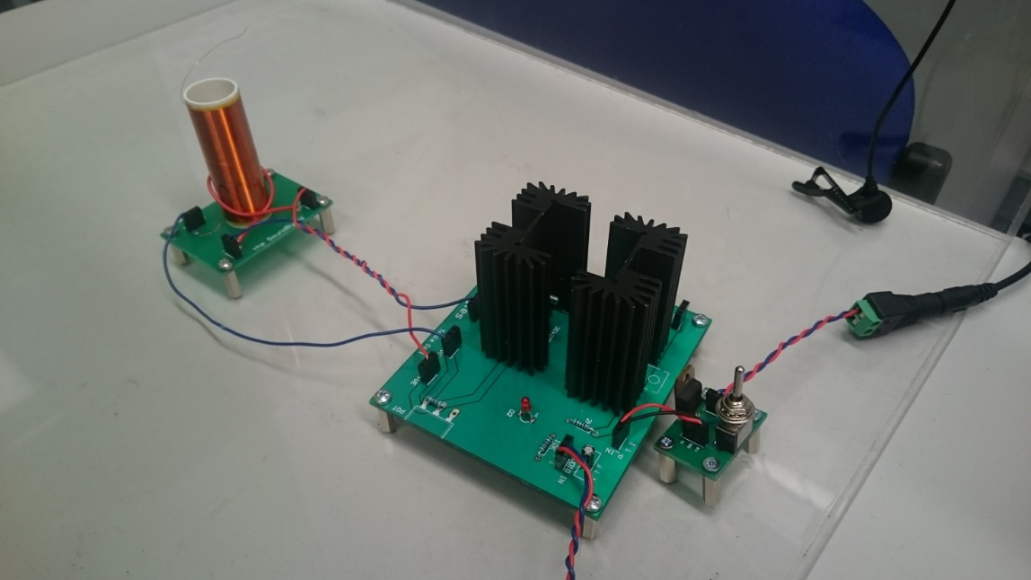

Tesla Coil

High frequency oscillation circuit

Microphone

Power Switch

Figure 3.32 Tesla coil instrument

With these modifications a new PCB was printed. An alternative method was explored, which involved creating two separate PCBs to mount the transistor on. Creating these meant that the new, larger heatsinks could be mounted on the transistors, increasing the longevity of the circuit. It also meant that, if the reprint of the PCB did not work then there was an alternative solution. There was also a PCB for the power switch made so the tesla can be turned off in-between songs to limit the amount of power the heatsinks have to dissipate. This includes a manual switch and a PNP transistor that can be turned on and off by the microcontroller. The TIP126 PNP transistor was one available from the school stores and was rated for 80V and had a gain of 1000 so, to make sure the transistor allows 2 A to flow a 1.2 kΩ resistor was used, giving a collector current of 2.5A

A Teensy microcontroller board and DSS were used to control the tesla coil so it works in the same way as the stepper with a few changes, such as different tracks to be played and a switch to turn off the tesla between uses.

To amplify the Tesla Coil a microphone was chosen to pick up the sound. This utilised an amplifier circuit (explained in Section 3.5.9) to amplify the microphone output, so it could be connected it to the speaker. The tesla coil will be housed in a box to keep it from being touched by observers, so it can be used safely as part of the orchestra. The health and safety document for the coil is in the appendix.

### Testing

### Summary

# Summary

## Achievements compared to Aims and Objectives

## Progress against GANTT chart presented in Interim Report

The GANTT charts presented in Figure 4.1, Figure 4.2 and Figure 4.3 show the progression of the team in Semester 2.

### Block 3

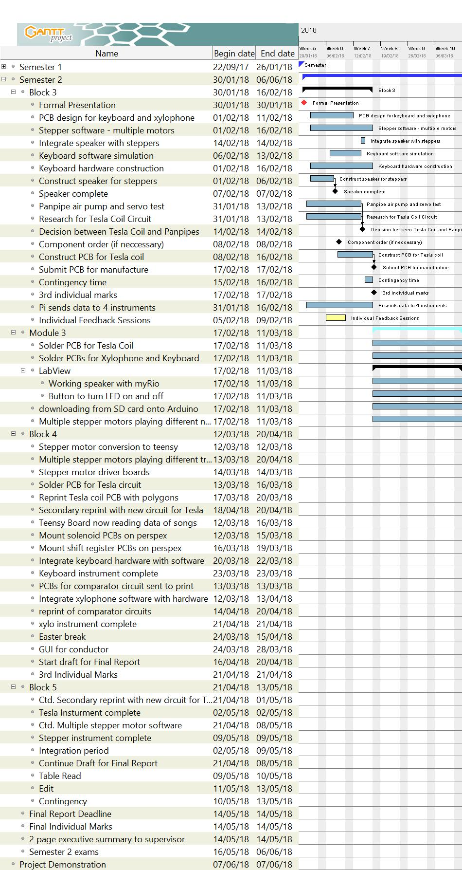

Figure 4.1 GANTT Chart for Block 3 in Semester 2

The initial plan for Block 3 of Semester 2 can be seen in Appendix G of the Interim Report (Appendix 7.3). After the formal presentation was delivered, the main tasks that needed to be completed by the end of the block included solving the issue of multiple notes being played on the stepper motors and finishing the development process of the Tesla coil and Panpipes. When meeting at the beginning of Project Block 3, a date for the decision between the two was set for the 7th February. As can be seen, the decision was delayed until 14th February. This was for several reasons. The circuit diagram that accompanied the miniature Tesla coil kits did not accurately represent the PCB that was provided in the kit. This slowed the development of the Tesla coil as it took longer to accurately determine how the circuit works and apply it to the project. In addition to this, it was difficult to find parts for the panpipe prototype that were able to be delivered within a short time frame. A new deadline was created to provide more time to research the ideas before coming to hard decision. Any extension past the new deadline would have left only two weeks to finish the development of the instrument, if the original project plan was to be maintained.

Developing the stepper motor software also took longer than expected. This was due to difficulty in finding a solution for the driver boards not functioning correctly. Initially, this was thought to be because the driver boards had been ordered from a third-party seller on eBay, so they may have been faulty. Another set of the same model of driver board were ordered. This incurred a delay that meant the task could not be completed within this project block, since the components were not available with next day delivery. This delay meant that the task of getting the stepper motor to communicate with the conductor had to be delayed and could not be started in the next project block.

The keyboard software was successfully constructed during this block and simulated using the Serial Monitor. The next stages were to construct the hardware and integrate the two together.

### Block 4

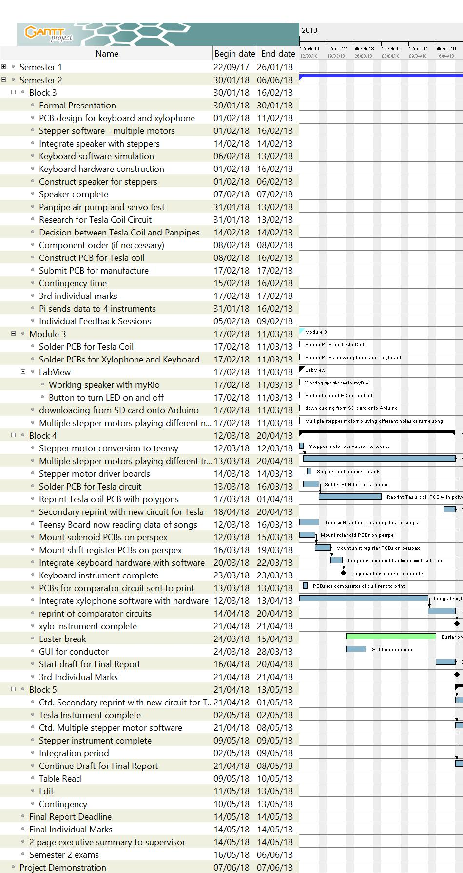

Figure 4.2 GANTT Chart for Block 4 in Semester 2

The original plan shown in Appendix G of the Interim Report (Appendix 7.3) set the deadline for completion of the Tesla coil to be at the end of the first week of block 5. As can be seen, the instrument was not completed in the project block. When the first iteration of the Tesla coil PCB was received from the workshop it was found that there were several mistakes on the board, which may have been as a result of team members not being very familiar with Altium. In a project of this nature, where the printing of PCBs is not controlled by the team members, making mistakes on boards can be costly. To mitigate this, each iteration of the plan has factored in the time it takes for a board to be printed (approximately a week). However, when a board must be reprinted it will still incur significant delay on the project. In this case, the completion of the Tesla Coil instrument was not completed until the end of the first week of the fifth block. After these initial mistakes were made, one of the solutions incorporated by the team was to ensure that PCB designs were checked by another team member, specifically the team members that had more experience in designing the boards. This proved to be an effective method and meant that the amplifier circuit for the xylophone and tesla and the comparator circuits for the xylophone were correct on the first attempt.

### Block 5

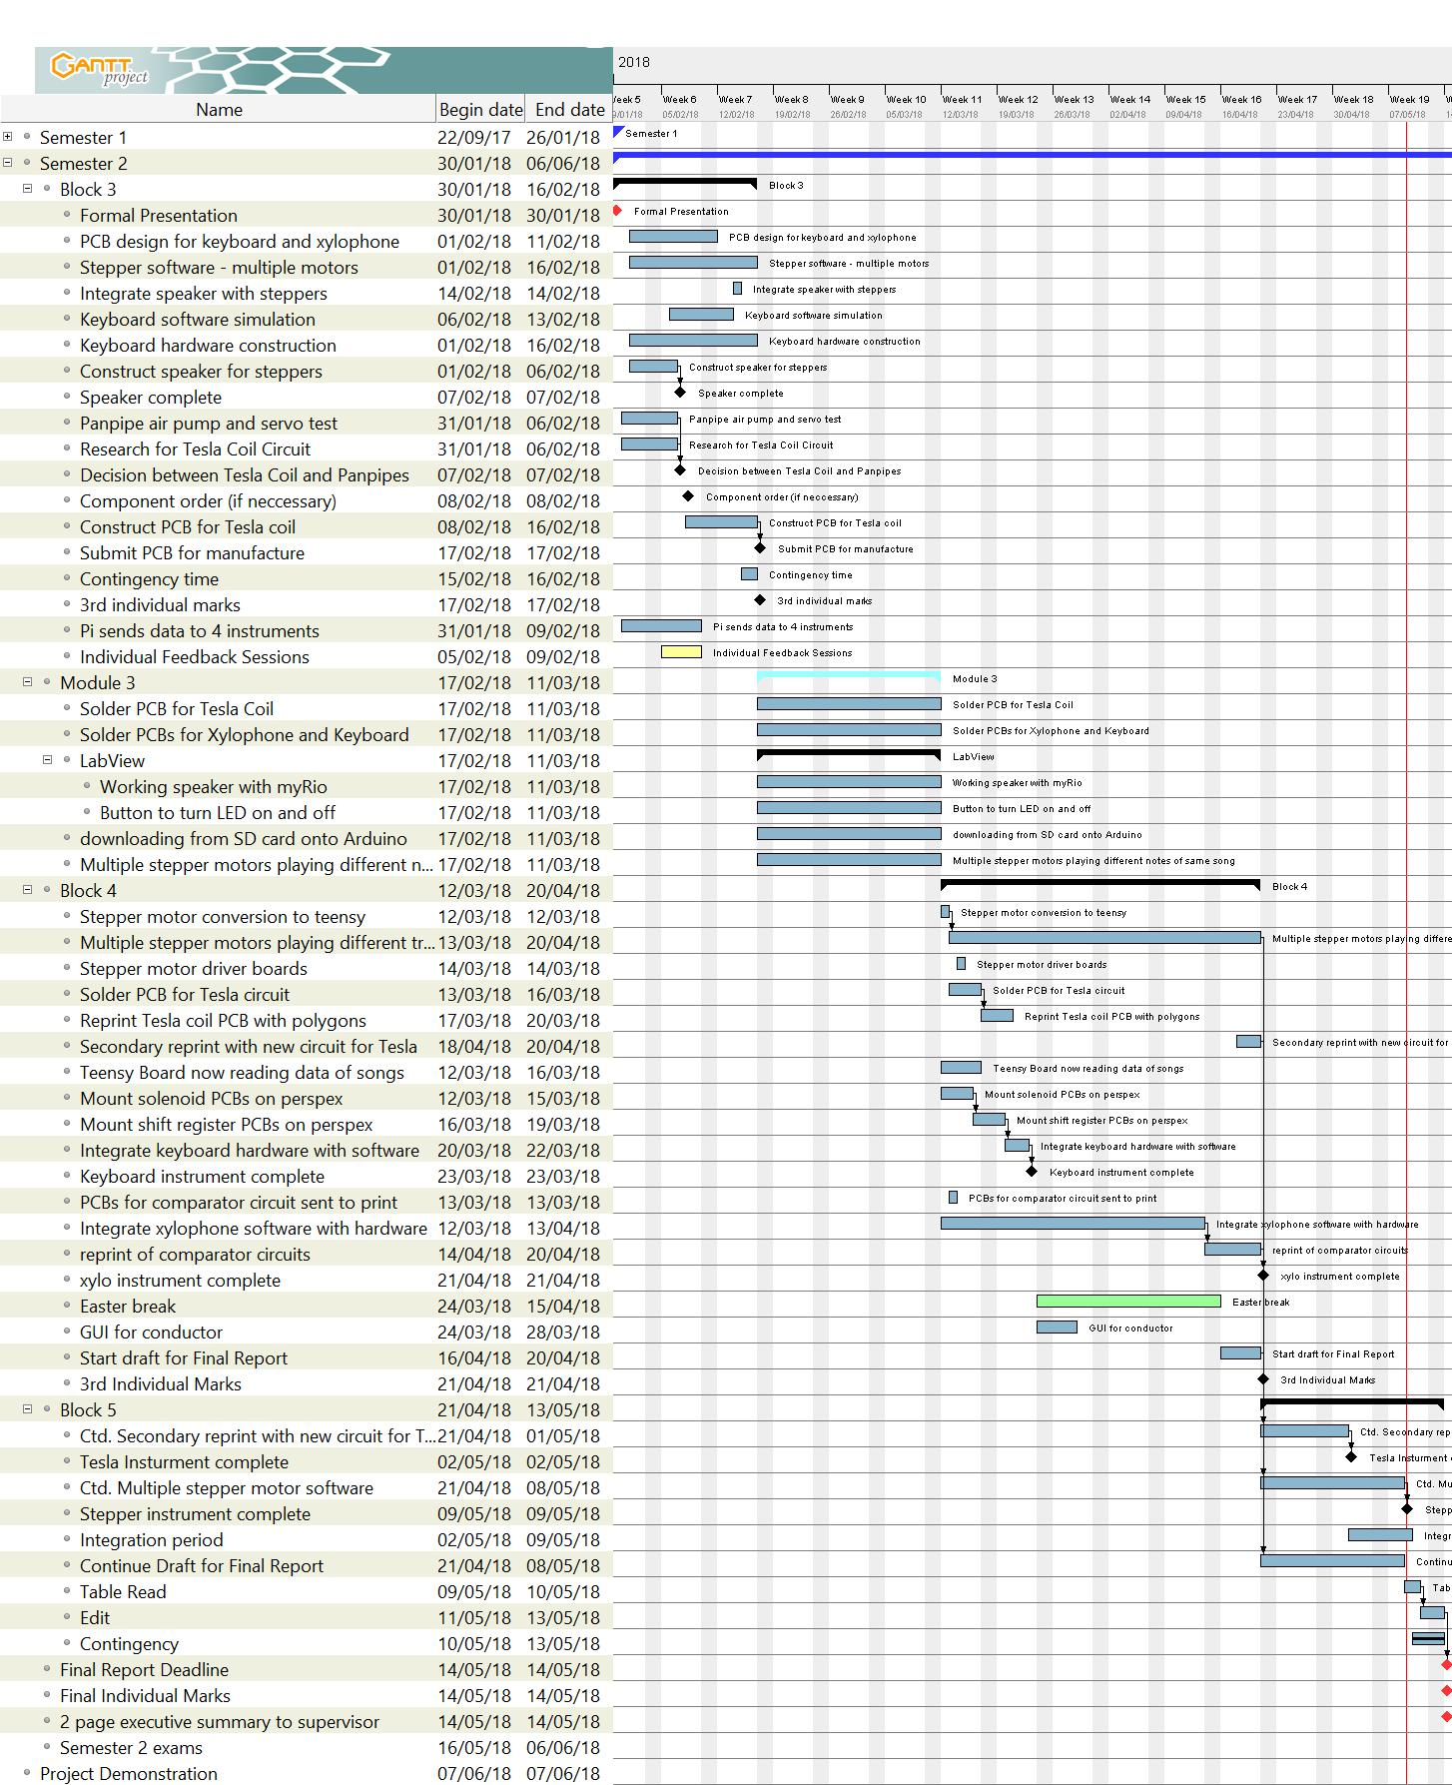

Figure 4.3 GANTT Chart for Block 5 in Semester 2

## Future Work

The keyboard instrument has been completed and is capable of playing any song as long as the song contains the notes shown in Appendix 7.4. To develop the keyboard further, stronger solenoids could be used to replace the current ones. Currently, the position of the solenoids must be precise to ensure they push down on the keys. Stronger solenoids would mean that the solenoids would not need to be mounted as precisely and would still be able to push down the keys.

The stepper motors instrument has been completed, being able to play a wide variety of songs while maintaining the integrity of the original song. However, the instrument can be further improved by increasing the number of motors so that songs that have more than four notes played at the same time can be replicated. Additionally, a dedicated sound amplification circuit could be developed so that the sound level of the instrument can be easily tuned.

In terms of software, the xylophone could be improved in two ways. Firstly, the direct interaction of the user with the instrument. In more detail, the user will be given two mallets in order to hit the piezoelectric sensors (which are attached on the keys) and produce a melody. That melody then, will be saved in a file directory of the MyRIO (like the other songs) giving the possibility to be accessed and played by the xylophone at a later date. The second update arises from the first improvement, i.e. the xylophone needs not only to receive information from the conductor, but also to send. By doing so, the xylophone is able to generate songs; for instance, the song that is produced from the user and saved in the xylophone, can be passed in the conductor and correspondingly shared within all the instruments of the orchestra, therefore the orchestra will be able to reproduce the user’s song.

## Management of the Project

This section focused on the management style of the project and highlights factors that worked well and what could be improved.

### Meetings

In the early stages of the project, the team would meet at least three times a week to go through the design of each of the instruments. This high level of frequency was important as each member of the team had to be involved with the design of each instrument to see ways that hardware or software could be shared between the instruments, simplifying the design. As the project progressed, and the nature of the work changed from being focused on design to being focused on technical execution, this frequency of meetings became a hinderance as they took time away from individual members that could have been executing their own technical work. To solve this, the style of the meetings was changed to reflect the technical work being executed. Instead of the team meeting as a whole, the individual sub teams would meet amongst themselves. This style of meeting reduced the time that team members were prevented from executing technical work.

Alongside this, each individual meeting, regardless of whether it was with the team or amongst the team had an established agenda. The agenda for both supervisor and team meetings was circulated within 24 hours of the start of the meeting. During supervisor meetings, minutes were taken to record any actions and important points determined. These minutes were formally written and uploaded to the Google Drive shared between all members of the team for reference. The minutes proved beneficial to the team. For example, when the first deliverable (Interim Report 1) was due, and a table read was conducted with the supervisors, it was useful to have the minutes to log the actions from the meetings so that any changes discussed could be executed.

### Procurement

The team had an allocated budget of £1500 and in the beginning of the project the university’s Robot Orchestra team offered to help with expenditures if the allocated budget would not be sufficient. For the project, £1474 have been spent on instruments, electronic components and building materials to develop all elements of the orchestra. The full record is presented in Appendix 7.16.

Approximately £300 has been spent on testing and developing costs such as solenoids, PCBs and microcontrollers. For example, the issue with the Arduino not having enough memory cost £130, as three Teensy 3.5 microcontrollers had to be purchased.

In addition to this, when deciding between the Tesla coil and panpipes a budget was not allocated for the development of these two instruments which meant that a significant portion of the budget was spent on developing the panpipes. They cost £168.11 to test and develop before they were dropped in favour of the Tesla coil. This meant they accounted for 11.21% of the budget, the only instrument that cost more than this was the keyboard (£404, 26.93% of the budget). Given that the team came very close to using the entire budget, it would have proved beneficial to set a cap on how much money was to be spent on the development of the panpipes, especially since the instrument did not form a part of the orchestra. In future projects like this, it would be beneficial to set budget targets for each of the instruments dependent on the complexity of their designs, ensuring that there is a buffer in the budget to account for mistakes that will be made during the project.

Despite this, if all the prototyping costs mentioned above are not considered, building a new orchestra using the technical work undertaken during the project would cost approximately £900, much lower than the team’s allocated budget.

### Outreach Activities

Currently the team have used the instruments in the new robot orchestra and participated in the IET Faraday Event for 40, Year 8 students [63]. The keyboard, stepper motors and xylophone instrument were taken to demonstrate at the event with each of them playing the Game of Thrones theme song. After the event, some feedback sheets were sent to the participating schools. The feedback received indicated that the demonstrations were very well received and achieved the task of encouraging young people to pursue a career in the technical sciences. One of the teachers from the schools commented:

*“A big thank you again, our group found the projects really interesting! Really helps raising the aspirations of our students who now say they’d like to go to university too!”*

This shows that the orchestra is promoting engineering in a more accessible, so it falls in line with the aims of the previous orchestra. Currently, the expansion of the orchestra has been accepted to appear at the competitive MOSI Maker Fest, where all four of the instruments mentioned in this report will be present for members of the public to interact with. The typical audience at the Maker Fest is 8-14-year olds and so it suits the target audience for this project.

# Conclusion

# References

|  |  |
| --- | --- |
| [1] | BBC, “BBC Radio 1 - Can a robot replace Ed Sheeran?,” BBC, 3 April 2018. [Online]. Available: http://www.bbc.co.uk/programmes/p04sxvgw. [Accessed October 2017]. |
| [2] | The University of Manchester, “European City of Science | The University of Manchester | Science and Engineering,” The University of Manchester, April 2018. [Online]. Available: http://www.se.manchester.ac.uk/about-us/ecos/. [Accessed November 2017]. |
| [3] | Robot Orchestra, “Hall of the Mountain King - Cover by Manchester Robot Orchestra,” YouTube, 31 August 2017. [Online]. Available: https://www.youtube.com/watch?v=PVr3PSUQtN0. [Accessed October 2017]. |
| [4] | C. O. 2. J. Hart, “Los Olivos, "Musical Notes Explaned Simply," theprovincialscientist,,” [Online]. Available: http://theprovincialscientist.com/?p=1576. [Accessed 2017]. |
| [5] | T. Correct, “MIDI numbering, the Helmholtz Pitch Notation System,” 2017. [Online]. Available: http://www.theoreticallycorrect.com/Helmholtz-Pitch-Numbering/. |
| [6] | MIDI Organisation, “The Official MIDI Specifications,” November 2017. [Online]. Available: ttps://www.midi.org/specifications/item/the-midi-1-0-specification.. |
| [7] | J. Gibson, “Introduction to MIDI and Computer Music: The MIDI Standard,” Indiana University, 2013. [Online]. Available: http://www.indiana.edu/~emusic/361/midi.htm. |
| [8] | MIDI Association, “Cabot- MIDI Cahon,” MIDI Association, 26 March 2017. [Online]. Available: https://www.midi.org/articles/an-intro-to-midi. |
| [9] | S. Richard , “MIDI Programming - A Complete Study,” http://www.petesqbsite.com, 11 February 2006. [Online]. Available: http://www.petesqbsite.com/sections/express/issue18/midifilespart1.html. [Accessed November 2017]. |
| [10] | CSIE.ntu.edu.tw, “The MIDI File Format,” CSIE.ntu.edu.tw, 26 March 2016. [Online]. Available: https://www.csie.ntu.edu.tw/~r92092/ref/midi/. [Accessed November 2017]. |
| [11] | S. Sugano and I. Kato, “WABOT-2: AUTONOMOUS ROBOT WITH DEXTEROUS FINGER-ARM,” IEEE Xplore, Raleigh, NC, USA, USA, 1987. |
| [12] | Teotronica, “robot playing piano,” YouTube, 14 September 2009. [Online]. Available: https://www.youtube.com/watch?v=HHcgTbs7\_Os. [Accessed October 2017]. |
| [13] | T. E. o. E. Britannica, “Ideophone, MUSICAL INSTRUMENT,” [Online]. Available: https://www.britannica.com/art/idiophone. [Accessed 7 May 2018]. |
| [14] | DK, “Xylophone,” [Online]. Available: https://www.dkfindout.com/us/music-art-and-literature/musical-instruments/xylophone/. [Accessed 7 May 2018]. |
| [15] | S. Theory, “Learning the Pentatonic scale,” [Online]. Available: http://www.simplifyingtheory.com/pentatonic-scale/. [Accessed 7 May 2018]. |
| [16] | SoftSchools, “Xylophone Facts,” [Online]. Available: http://www.softschools.com/facts/music\_instruments/xylophone\_facts/3003/. [Accessed 7 May 2018]. |
| [17] | E. Estrella, “What is a Chromatic Scale?,” 09 April 2018. [Online]. Available: https://www.thoughtco.com/what-is-a-chromatic-scale-2456561. [Accessed 10 May 2018]. |
| [18] | J. deBoisblanc, “Arduino: how to build an electronic MIDI xylophone,” YouTube, May 2011. [Online]. Available: https://www.youtube.com/watch?v=92VIEDtQKVI. [Accessed 2017 October]. |
| [19] | MrSolidSnake745, “Toy Story - You've Got A Friend In Me {4 SM},” 26 April 2016. [Online]. Available: https://www.youtube.com/watch?v=RhyvsieEyas. [Accessed May 2018]. |
| [20] | 김진철, “Supermario theme Stepping motor,” 14 October 2014. [Online]. Available: https://www.youtube.com/watch?v=XYrb1ZV8E-U. [Accessed May 2018]. |
| [21] | O. Engineering, “What is a stepper motor? - Principles, types and controllers,” Omega, 2017. [Online]. Available: https://www.omega.co.uk/prodinfo/stepper\_motors.html. [Accessed May 2018]. |
| [22] | “NEMA Stepper Motors & Controllers,” 2017. [Online]. Available: https://www.circuitspecialists.com/stepper-motor. [Accessed May 2018]. |
| [23] | D. Nedelkovski, “How a Stepper Motor Works,” HowToMechatronics, [Online]. Available: https://howtomechatronics.com/how-it-works/electrical-engineering/stepper-motor/. [Accessed May 2018]. |
| [24] | C. Woodford, “How does a stepper motor work,” ExplainThatStuff, January 2018. [Online]. Available: http://www.explainthatstuff.com/how-stepper-motors-work.html. [Accessed May 2018]. |
| [25] | M. C. G. Y. N. K. K. Y. Leung, “Effect of ultrasound on acute inflammation of transected medial collateral ligaments,” *Archives of physical medicine and rehabilitation,* 2004. |
| [26] | R. S. F. M. M. a. T. J. M. Colby, “Vibration modes and acoustic noise in a four-phase switched reluctance motor,” *IEEE Transactions on Industry Applications,* 1996. |
| [27] | G. Johnson, “Building the world's largest Tesla coil-history and theory,” in *Proceedings of the Twenty-Second Annual North American Power Symposium*, 1990. |
| [28] | M. Farriz, A. Din and A. Rahman, “A Simple Design of a Mini Tesla Coil with DC Voltage Input,” in *Electrical and Control Engineering (ICECE), 2010 International Conference*, 25-27 June 2010 . |
| [29] | TheHomebrewGuru, “Build and Code a MONSTER Musical Tesla Coil With a Microcontroller,” instructables, [Online]. Available: http://www.instructables.com/id/Build-a-Musical-Tesla-Coil-like-a-Pro/. [Accessed 06 05 2018]. |
| [30] | M. Krbal and P. Siuda, “Design and construction solution of laboratory Tesla coil,” in *Electric Power Engineering (EPE), 2015 16th International Scientific Conference on*, 20-22 May 2015. |
| [31] | C.-D. Ghilinţă, S. C. Stegaru and T. Popeea, “Portable audio-modulated Tesla coil for demonstrative actions,” in *RoEduNet International Conference - Networking in Education and Research (RoEduNet NER)*, 2015 14th. |
| [32] | teslacoildesign, “Construction,” teslacoildesign, [Online]. Available: http://www.teslacoildesign.com/construction.html. [Accessed 06 05 2018]. |
| [33] | T. Coiler, “Step by Step Plans to Building a 250,000 Volt Tesla Coil. (REVISED VERSION),” instructable, [Online]. Available: http://www.instructables.com/id/Step-By-Step-Plans-to-Building-a-250000-Volt-Tesl/. [Accessed 06 05 2018]. |
| [34] | P. D. A. Aziz, A. L. A. Razak and M. I. A. Bakar, “A study on wireless power transfer using tesla coil technique,” in *Sustainable Energy Engineering and Application (ICSEEA), 2016 International Conference on*, 09 March 2017 . |
| [35] | R. K. Golka, “Long Arc Simulated Lightning Attachment Testing Using a 150 kW Tesla Coil,” in *Electromagnetic Compatibility, 1979 IEEE International Symposium on*, 9-11 Oct. 1979 . |
| [36] | E. Goodchild, “"In the Hall of the Mountain King" - Played on Musical Tesla Coils,” Youtube, [Online]. Available: https://www.youtube.com/watch?v=8LAhKkPUo\_A. [Accessed 23 November 2017]. |
| [37] | C. S. a. T. Padfield, “The effect of moisture on the performance of woodwind instruments,” [Online]. Available: http://www.conservationphysics.org/flute/flute.php. |
| [38] | K. T. T. N. T. Y. a. A. T. J. Solis, “Development of Waseda Flutist Robot WF-4RIV: Implementation of auditory feedback system,” IEEE International Conference on Robotics and Automation, Pasadena, 2008. |
| [39] | A. T. a. K. H. J. Solis, “Development of an Anthropomorphic Saxophone-Playing Robot,” Springer-Verlag, Berlin, 2010. |
| [40] | T. Dare, “TeamDARE's robot band plays "Rolling in the deep",” YouTube, 2011. [Online]. Available: https://www.youtube.com/watch?v=RKpKygGX2Nk. [Accessed November 2017]. |
| [41] | Texas Instruments, September 2015. [Online]. Available: http://www.ti.com/lit/ds/symlink/sn74hc595.pdf. |
| [42] | Willow Software, “Anvil Studio,” [Online]. Available: https://www.anvilstudio.com/. [Accessed 2017]. |
| [43] | Digi-Key Electronics, “Teensy 3.5 Development Boards,” Digi-Key Electronics, May 2017. [Online]. Available: https://www.digikey.co.uk/en/product-highlight/s/sparkfun/teensy-3-5-development-boards?utm\_adgroup=General&mkwid=soH81BotU&pcrid=153579592989&pkw=&pmt=b&pdv=c&gclid=Cj0KCQjwzcbWBRDmARIsAM6uChWvHjF2Fet7RmA1V3Q-BrLNvw1TbjsVR3pmN3F87623KgCN4sJ8ktsaAgMdEALw\_. [Accessed April 2018]. |
| [44] | Arduino, “bitWrite(),” Arduino, November 2008. [Online]. Available: https://www.arduino.cc/reference/en/language/functions/bits-and-bytes/bitwrite/. [Accessed April 2018]. |
| [45] | J. Electronics, “LM741 Operational Amplifer,” National Semiconductor, 2000. [Online]. Available: https://www.jameco.com/Jameco/Products/ProdDS/840763.pdf. |
| [46] | Future Electronics, “What is a UART?,” Future Electronics, 8 March 2012. [Online]. Available: http://www.futureelectronics.com/en/Signal-Interface/uart.aspx. [Accessed February 2018]. |
| [47] | TechTarget, “UART (Universal Asynchronous Receiver/Transmitter),” TechTarget, February 2011. [Online]. Available: https://whatis.techtarget.com/definition/UART-Universal-Asynchronous-Receiver-Transmitter. [Accessed February 2018]. |
| [48] | Atlantic.net, “What Is UART (Universal Asynchronous Receiver/Transmitter),” Atlantic.net, 28 September 2015. [Online]. Available: https://www.atlantic.net/cloud-hosting/what-is-uart-universal-asynchronous-receiver-transmitter/. [Accessed February 2018]. |
| [49] | D. F. a. W. H. A. Thierauf, “Vibraphone Samples,” University of Iowa, 2013. [Online]. Available: http://theremin.music.uiowa.edu/. |
| [50] | MakerHub, “Use an array to play sound in MyRIO,” 2014. [Online]. Available: https://www.labviewmakerhub.com/forums/viewtopic.php?f=14&t=372&sid=6eefbf8b8e0023df0de644daf7a99954&start=10. |
| [51] | Visaton, “Speaker FR-10,” Viston Germany, 2016. |
| [52] | C. Basics, “Build a great sounding audio amplifier from the LM386,” [Online]. Available: http://www.circuitbasics.com/build-a-great-sounding-audio-amplifier-with-bass-boost-from-the-lm386/. |
| [53] | T. Instruments, “LM386 Low Voltage Audio Power Amplifier,” TI, 2017. |
| [54] | Analog Devices, “Low Power, 8.5 mW, 2.3 V to 5.5 V, Programmable Waveform Generator,” 2012. [Online]. Available: http://www.analog.com/media/en/technical-documentation/data-sheets/AD9837.PDF. [Accessed 2018 May]. |
| [55] | Texas Instruments, “DRV8825 Stepper Motor Controller IC,” July 2014. [Online]. Available: http://www.ti.com/lit/ds/symlink/drv8825.pdf. [Accessed May 2018]. |
| [56] | Spooled Canada, “NEMA17 Stepper Motor - 34mm,” [Online]. Available: https://spool3d.ca/nema17-stepper-motor-34mm/. [Accessed May 2018]. |
| [57] | Leung, C. Mason, Y. N. Gabriel and K. Yip, “Effect of ultrasound on acute inflammation of transected medial collateral ligaments,” *Archives of physical medicine and rehabilitation,* vol. 85, no. 6, pp. 963-966, 2004. |
| [58] | Polulu Robotics & Electronics, “DRV8825 Stepper Motor Driver Carrier, High Current,” Polulu Robotics & Electronics, [Online]. Available: https://www.pololu.com/product/2133 . [Accessed May 2018]. |
| [59] | Instructables, “STEP BY STEP PLANS TO BUILDING A 250,000 VOLT TESLA COIL. (REVISED VERSION),” Instructables, February 2009. [Online]. Available: http://www.instructables.com/id/Step-By-Step-Plans-to-Building-a-250000-Volt-Tesl/. [Accessed January 2018]. |
| [60] | Noise Help, “Noise Level Chart,” Noise Help, 27 December 2010. [Online]. Available: http://www.noisehelp.com/noise-level-chart.html. [Accessed January 2018]. |
| [61] | H. a. S. Executive, “Managing the risks from hot water and surfaces,” Health and Safety Executive, 2012. |
| [62] | “Burn Exposure Chart,” Antiscald.com, [Online]. Available: http://antiscald.com/index.php?route=information/information&information\_id=15&arubalp=3bc10d3e-c7c0-4be3-a37d-74d704d7da. [Accessed 07 05 2018]. |
| [63] | IET, “IET Faraday Secondary,” IET, 23 August 2017. [Online]. Available: https://faraday-secondary.theiet.org/. [Accessed April 2018]. |
| [64] | A. Kapur, “A History of Robotic Musical Instruments,” University of Victoria, Music Intelligence and Sound Technology. |
| [65] | B. Nomate, “Compressorhead - Ace of Spades,” Compressorhad, November 2017. [Online]. Available: https://www.youtube.com/watch?v=xP4sYKR4NUc. |
| [66] | J. Shauw, “Dream wedding played by piano robot,” YouTube, 7 November 2010. [Online]. Available: https://www.youtube.com/watch?v=IwuiOwZrzCM. [Accessed October 2017]. |
| [67] | Electronics Tutorials, “Breakdown voltage/Dielectric strength (Breakdown of Insulator),” Electronics Tutorials, September 2015. [Online]. Available: https://electronicspani.com/breakdown-voltagedielectric-strength/. [Accessed January 2018]. |

# Appendices

## Project Proposal

**Project Proposal**

**Project Title:** New core infrastructure for the Robot Orchestra

**Supervisors:** Prof Danielle George and Dr William McGenn

**Industrial Involvement:** National Instruments, Siemens, EPSRC, The Granada Foundation

**Overall Aim and Objectives of the Project:**

The aim of this project is to develop a 4-piece (min) robot music band/orchestra with a robot conductor. The Robot Orchestra is a project that fuses engineering with music/arts in order to give people a new perspective on engineering, highlight the creativity of engineering to prospective employees and reach audiences that are traditionally under-represented in the engineering sector. The instruments in the current orchestra have been made by school children, university students, maker groups and other members of the public, and use a wide variety of software and hardware platforms.

This project will involve building and developing a new core infrastructure for the Robot Orchestra that will be stand-alone as well as increase the flexibility, usability and reliability of the existing orchestra. This will include building a new robotic conductor as well as building several new instruments and developing others to form a centre piece for the orchestra. These instruments should allow for as large a range of musical styles to be played as possible. This new core infrastructure for the Robot Orchestra should be usable independently or with existing instruments and any new instruments, irrespective of the hardware platform that has been used to build them.

**Tasks to be undertaken** (a list is preferred and brief explanation if necessary)

* The new core for the robot orchestra should consist of at least 4 instruments/robots; these can either be built from scratch or developed from pre-existing instruments in the orchestra. These should have visual elements as well as being musical in order to increase the visual appeal of the orchestra. The instruments chosen should allow for the core orchestra to be capable of playing a wide variety of styles of music.
* It is worth noting that the challenges involved will differ depending on the instruments chosen and the way that the instruments are played. Careful selection of the instruments and their implementation into robots will be one of the key challenges for the team, not only on a technical level but it is also a key challenge for the project management.
* Develop a conductor for controlling all of the instruments/robots, which should be capable of controlling those that are being built as part of this project, those that already exist in the orchestra and also have as much flexibility as possible to include any that could be built in the future.
* In order to increase the ease of use of the orchestra we would like to develop a common MIDI file interface for the conductor and the other instruments (where appropriate).
* In order to increase the flexibility of the orchestra, we would like the orchestra to be programmed to play a selection of different pieces of music (to be chosen and justified by the team) that will appeal to a range of different ages and tastes in music, and could also be used in different situations (during Robot Orchestra performances, live shows and demonstrations).

**Relevant Background Information** (attach as separate if necessary)

The Robot Orchestra is an EPSRC-funded outreach project led by Professor Danielle George at The University of Manchester, in collaboration with Siemens and the Granada Foundation plus many more. The project originally began as to celebrate Manchester being the 2016 European City of Science and has continued to develop this year. In 2017 the BBC filmed the orchestra on a number of occasions including at Maida Vale Studios in London.

The orchestra has been part of a UK engineering tour sponsored by the Royal Academy of Engineering and showcased at both the institution of Engineering and Technology and the Institution of Mechanical Engineers. It is envisioned that the professional standards of the Meng teams output will attract further attention from the professional bodies as well as industry.

**Other Information**

To give an idea of range of musical styles, currently the orchestra is set up to play Hall of the Mountain King (https://www.youtube.com/watch?v=kLp\_Hh6DKWc) and Ed Sheeran’s Shape of You (https://www.youtube.com/watch?v=\_dK2tDK9grQ). It is not necessary that the new orchestra developed as part of this project need to play either of the songs.

During performances the audience is generally made award of the experimental nature of the current orchestra and will as such give allowances for some technical/musical mishaps. However part of the aim of this project is to reduce the experimental nature of the orchestra as much as possible, and thereby minimising both technical and musical problems.

**More information about the Robot Orchestra can be found at the website and on social media**

Website: http://www.robotorchestra.co.uk

Instagram: https://www.instagram.com/robotsarecoming/

Twitter: http://twitter.com/robotsmcr (@robotsmcr)

In addition there are a number of films of the orchestra performing and that we have been included in

The Making of the Robot Orchestra: <https://www.youtube.com/watch?v=SQdIGueRKj4>

The Robot Orchestra at the Manchester Science Festival: <https://youtu.be/9v1Jr8TDo0A>

Can a Robot Replace Ed Sheeran? <http://www.bbc.co.uk/programmes/p04sxvgw>

and

<http://www.bbc.co.uk/programmes/articles/55sKXKxMjBb9jdVyRgJXM72/could-a-robot-replace-ed-sheeran>

What if… Robots Replaced Teachers: <http://www.bbc.co.uk/programmes/articles/50xFTZWjLhb0Rv5v76bXsNs/what-if-robots-replaced-teachers>

**Desirable Skills** (note that the majority of the class are EEE students – some skills are in short supply). H,M,L =High, Medium, Low priority.

|  |  |  |
| --- | --- | --- |
| Please fill in as many relevant requirements as you wish **Skills** | **Number of students** | **Priority**  **H,M,L** |
| Power Electronics | | |
| Power Systems | | |
| High Voltage | | |
| FPGA | 1 | M |
| Embedded System | 1 | H |
| Digital Signal Processing | | |
| Image Processing and Vision systems | | |
| Analogue Circuits | 1 | M |
| Software Engineering | 1 | H |
| Control | 1 | M |
| Data Analysis | | |
| Sensors and Instrumentation | 1 | M |
| Communication Systems | 1 | L |
| Silicon Fabrication/Clean room | | |
| Mechatronics | 1 | H |
| Robotics | 1 | M |
| Sensors | | |
| Other (specify) | | |
| Knowledge of music etc (in addition to the above technical skills) | 2 | L |

**Metrics (Norms) for Technical Delivery**

Write a short statement to suggest what a “typical” M.Eng team would be expected to deliver on this project to achieve the following classifications. It is suggested that these statements are based on no more than 10 criteria:

**First Class**

Satisfied the 2:1 level and in addition:

* Full automation
* The finished orchestra is capable of playing, and programmed to play, a wide range of different songs to suit a wide variety of audiences and situations.
* Steps have been taken to ensure that new instruments can be added to this core orchestra in the future without needing the make changes to this core, irrespective of the hardware platforms to be added.
* Investigated further potential developments for increasing the interactivity of the orchestra
* Well thought out solutions for how the orchestra can be transported and set up to minimise the time set up/pack down takes.

One of the key differences between a 1st and a 2:1 is the quality of the final orchestra, the performance it is able to put on and its usability, i.e. how straightforward is it to operate, maintain and further develop. The key metric for evaluating the performance of the orchestra is recognisability of the song being played and the quality of the playing.

**Upper Second**

Satisfied the 2:2 level and in addition:

* The finished product is a fully working robot orchestra containing at least 4 instruments/robots that have been built/developed as part of the project. When performing all of the instruments play in time with each other and other visual elements are in sync with the music.
* The robotic conductor is capable of controlling the instruments/robots that have been built/developed as part of this project and also controlling those that already exist in the orchestra when desired. The conductor also has a midi file interface that is standardized with the other instruments in the orchestra. There is some degree of communication between the conductor and the instruments/robots to automate the change of song where appropriate.
* The instruments included in the orchestra have been well justified and will allow for a large range of different styles of music to be played, even if not currently programmed. All of the instruments/robots have a standardized midi file input. All of the robots also include well thought out and coordinated visual elements.
* Consideration has been paid to how the robots are to be transported and set up/packed down, and also to the general usability of the orchestra.

**Lower Second**

* Undertaken a literature review covering similar robotic instruments/orchestras and other relevant musical technology (e.g. Midi).
* Formulated a system specification for the orchestra.
* Investigated multiple design options for the conductor and the instruments/robots that could be included within the orchestra. This includes consideration of the instruments to be included to allow for a range of different styles of music to be played.
* The final product is a robot orchestra that consists of less than four instruments/robots or of only pre-existing instruments with minimal development. When performing the instruments do not play in time musically or the visual elements are not in sync with the music (or non-existent).
* Built a conductor that is capable of controlling instruments/robots that have been specifically developed as part of this project.
* No attention has been paid to the flexibility, usability and reliability of the orchestra.

## MIDI Notes

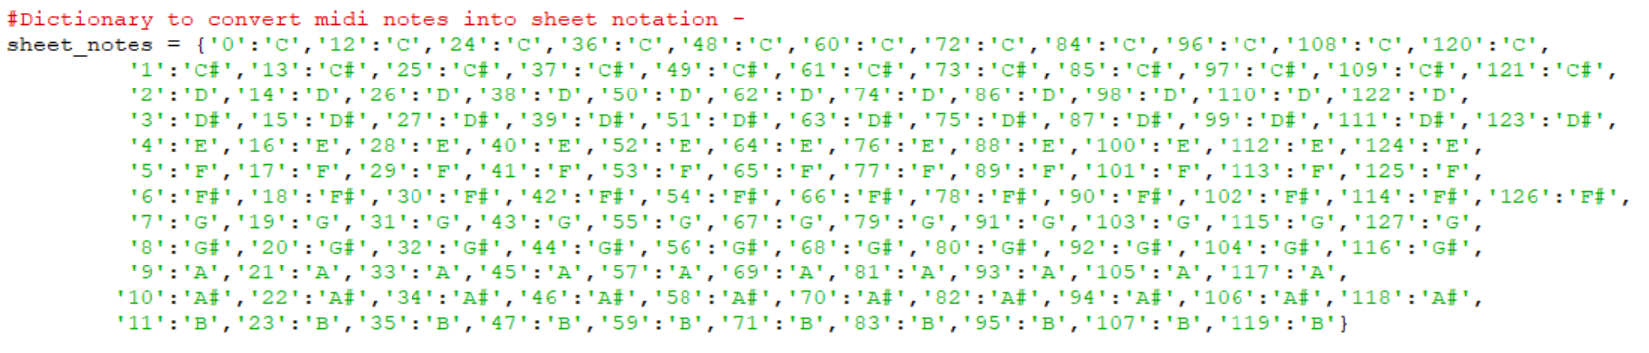

Figure 7.1. Binary values corresponding to musical notes

## Interim Report

**School of Electrical**

**and Electronic Engineering**



**Robot Orchestra**

**Interim Report**

**Group 11**

|  |  |  |
| --- | --- | --- |
| Group Members: | Buruiana, Andrei | 9478411 |
|  | Chanda, Joyanto | 9015629 |
|  | Dimou, Theodoros | 9126435 |
|  | Fumagalli, Francesco | 9017237 |
|  | Petrovs, Antons | 9474345 |
|  | Simpson, Joshua | 8929879 |

Tutors: Prof. Danielle George and Dr. William McGenn

Date: 26 November 2017

## Notes required by Keyboard

|  |  |  |  |  |
| --- | --- | --- | --- | --- |
| **Notes Requird** | | |  |  |
| **Califonication** | **Eye of Tiger** | **Game of Thrones** | **Note count** | **Type of Key** |
| 40 | 40 | 40 | 1 | w |
| 41 | 41 | 41 | 2 | w |
| 43 | 43 | 43 | 3 | w |
|  | 44 |  | 4 | b |
| 45 |  | 45 | 5 | w |
|  | 46 |  | 6 | b |
| 47 |  | 47 | 7 | w |
| 48 | 48 | 48 | 8 | w |
| 50 | 50 | 50 | 9 | w |
|  | 51 |  | 10 | b |
| 52 | 52 | 52 | 11 | w |
| 53 | 53 | 53 | 12 | w |
| 55 | 55 | 55 | 13 | w |
|  | 56 |  | 14 | b |
| 57 |  | 57 | 15 | w |
|  | 58 |  | 16 | b |
| 59 |  | 59 | 17 | w |
| 60 | 60 | 60 | 18 | w |
| 61 |  | 61 | 19 | b |
| 62 | 62 | 62 | 20 | w |
|  | 63 |  | 21 | b |
| 64 |  | 64 | 22 | w |
| 65 | 65 | 65 | 23 | w |
| 67 | 67 | 67 | 24 | w |
| 69 |  | 69 | 25 | w |

Table 8 Notes needed by the keyboard to play the three songs selected by the team.

Each number is the MIDI representation of a particular note.

## Amount of force required to play a key

|  |  |
| --- | --- |
| **Mass (g)** | **Did the key play?** |
| 5 | No |
| 10 | No |
| 20 | No |
| 30 | No |
| 40 | No |
| 50 | No |
| 60 | No |
| 70 | Yes |
| 80 | Yes |
| 90 | Yes |
| 100 | Yes |

Table 9 Amount of force required to play a key.

## Diagrams for supporting structure on the keyboard instrument

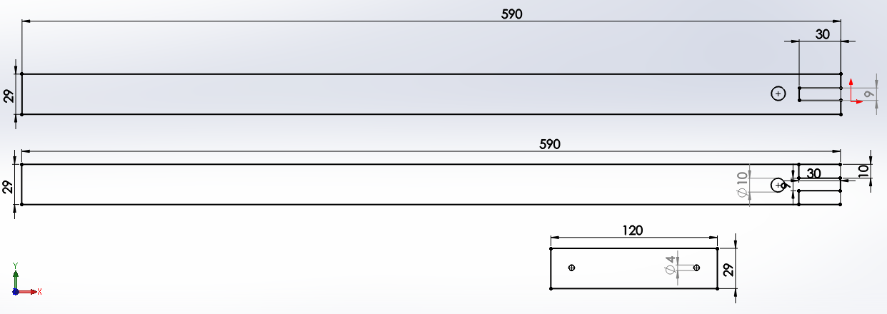

Figure 7.2 Keyboard base connector

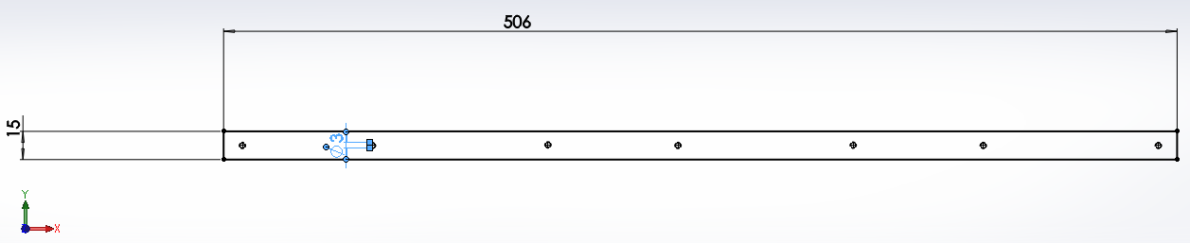

Figure 7.3 Support for solenoids to hold them in place

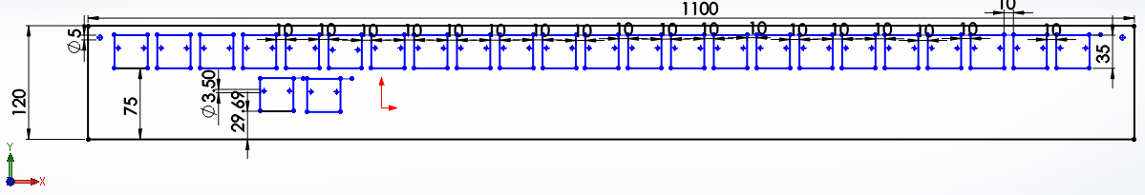

Figure 7.4 Keyboard Mounting Plate for Solenoids and Shift registers

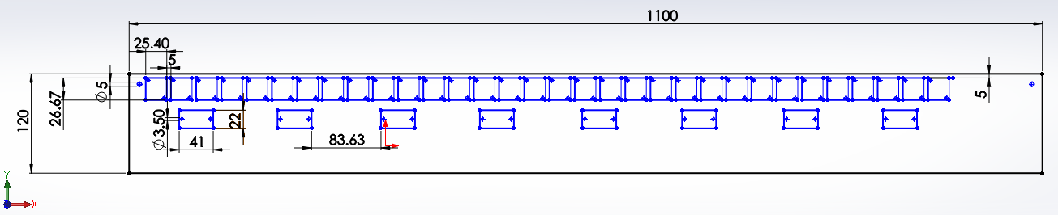

Figure 7.5 2nd version of Keyboard Mounting Plate for Solenoids and Shift registers

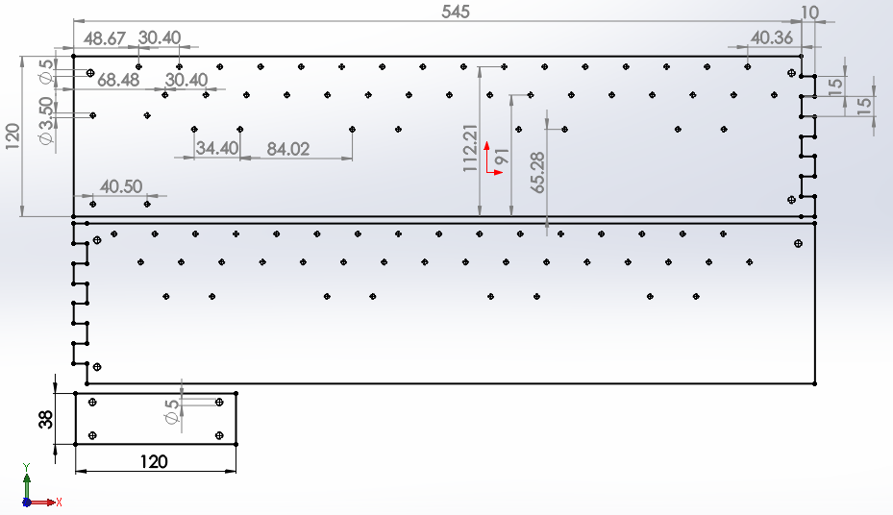

Figure 7.6 PCB Keyboard Mounting Plate

## Keyboard Testing

|  |  |  |
| --- | --- | --- |
| **Key** | **Did it produce a note?** | |
| **1** | **2** |
| 40 | Yes |  |
| 41 | Yes |  |
| 43 | Yes |  |
| 44 | Yes |  |
| 45 | Yes |  |
| 46 | No | Yes |
| 47 | Yes |  |
| 48 | Yes |  |
| 50 | Yes |  |
| 51 | Yes |  |
| 52 | Yes |  |
| 53 | Yes |  |
| 55 | Yes |  |
| 56 | Yes |  |
| 57 | Yes |  |
| 58 | Yes |  |
| 59 | Yes |  |
| 60 | No | Yes |
| 61 | Yes |  |
| 62 | Yes |  |
| 63 | Yes |  |
| 64 | Yes |  |
| 65 | Yes |  |
| 67 | No | Yes |
| 69 | Yes |  |

Table 10 Keyboard Testing

## Diagrams for structure on Xylophone

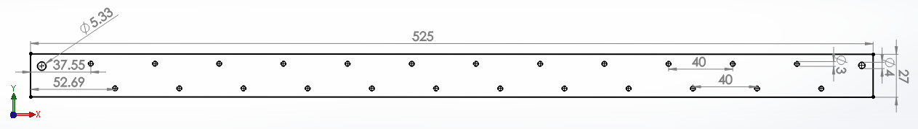

Figure 7.7 Mounting plate for solenoids of Xylophone

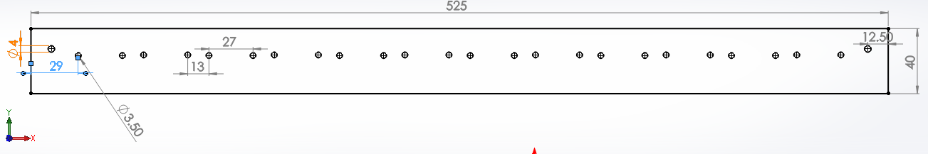

Figure 7.8 Mounting plate for comparators on Xylophone

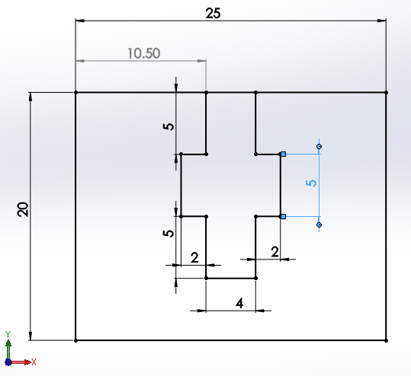

Figure 7.9 Xylophone base plate

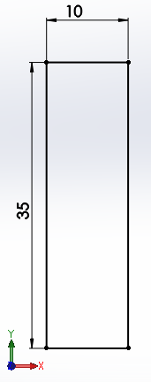

Figure 7.10 Structure to hold the sides of the Xylophone up

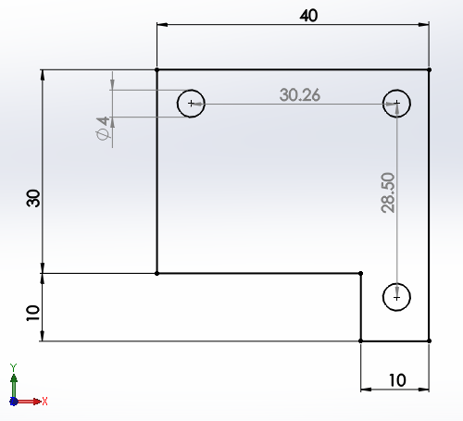

Figure 7.11 Plates for solenoids on Xylophone

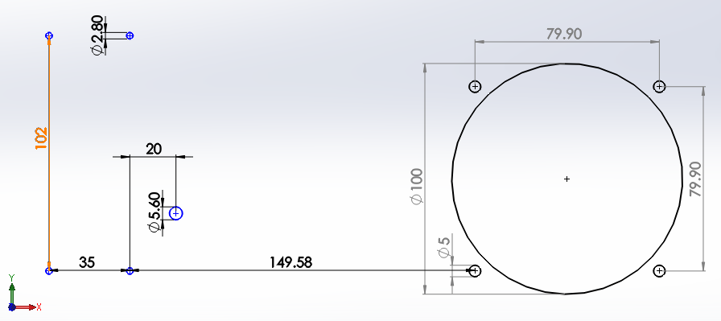

Figure 7.12 Xylophone speaker on side plate

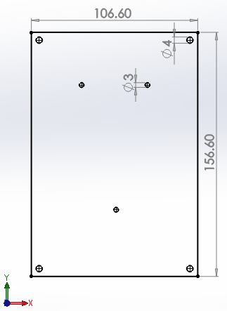

Figure 7.13 Mounting plate for the MyRIO to fix it to the Xylophone

## Front panel of LabVIEW code

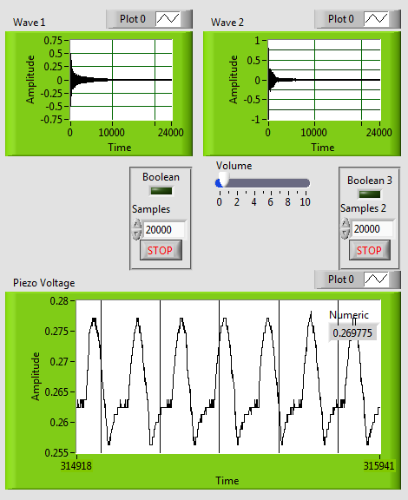

Figure 7.14. Front Panel of LabView Code when testing piezo sensors.

Wave 1 shows the sound waveform of the first piezo (one being tested through the analog pin)

Wave 2 shows the sound waveform of the second piezo (being tested through digital pin)

Piezo voltage shows the voltage produced by the piezo which is tested through the analog pin.

## Code for 12 keys to produce sounds

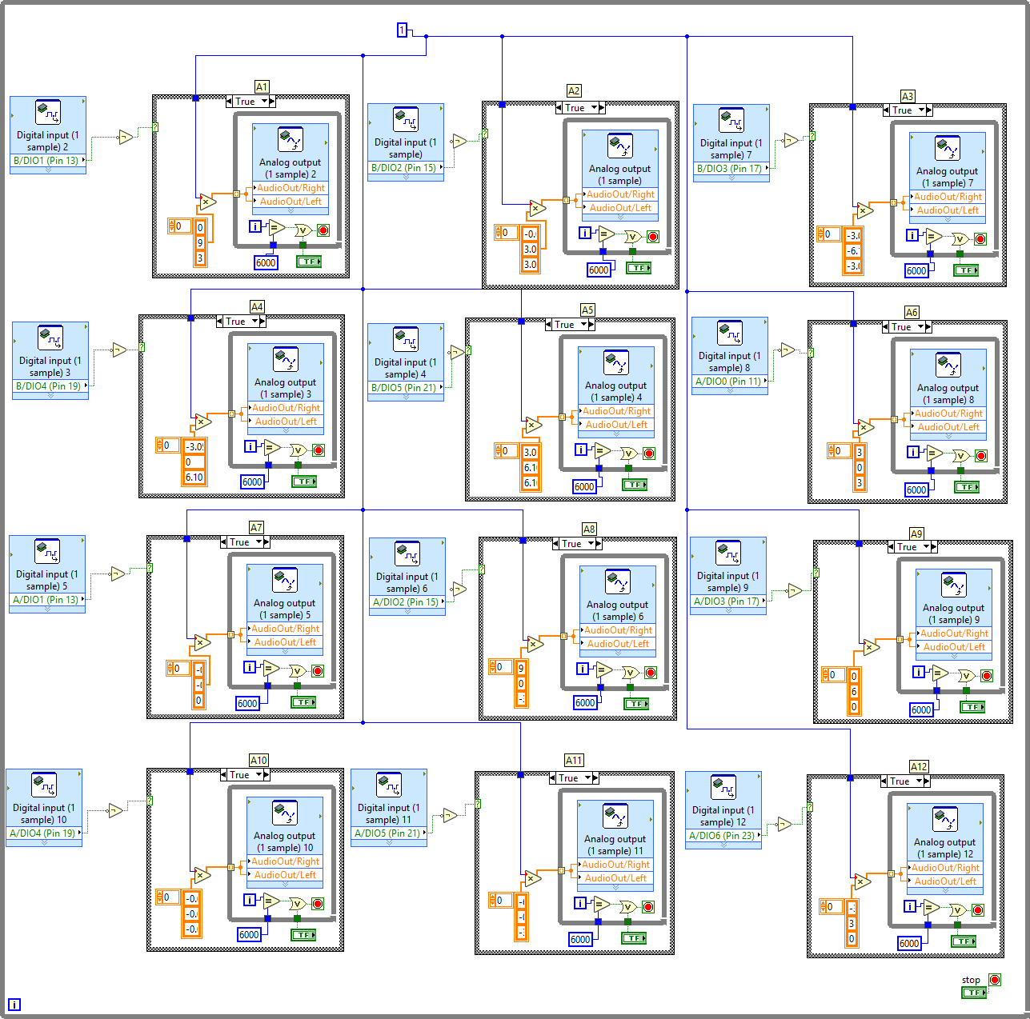

Figure 7.15. Code for 12 keys to produce 12 notes.

## PCB for Audio Amplifier Circuit

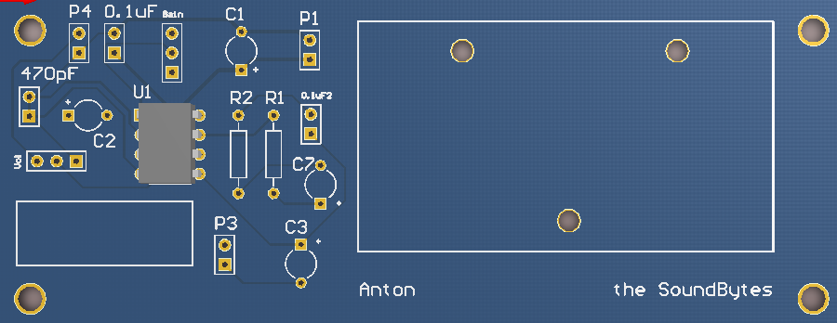

Figure 7.16. PCB of the audio amplifier circuit

## Appendix L

## DRV8825 Driver board Schematic

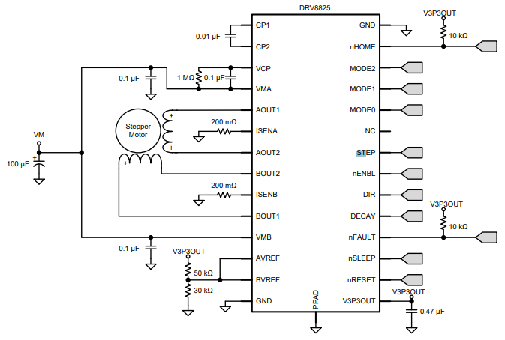

Figure 7.17 DRV8825 Driver Board Schematic used for the steppers

## Mini Tesla Coil Instruction Sheet

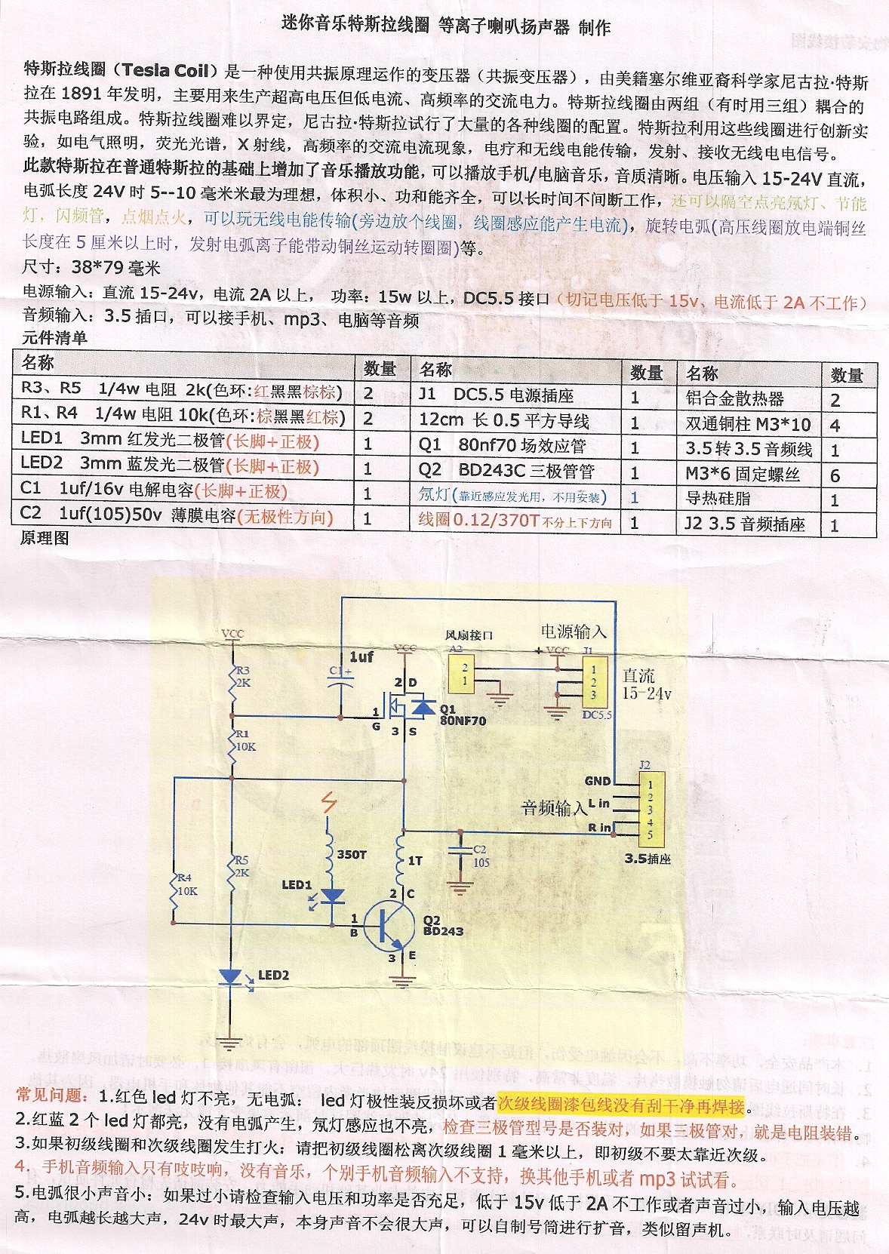

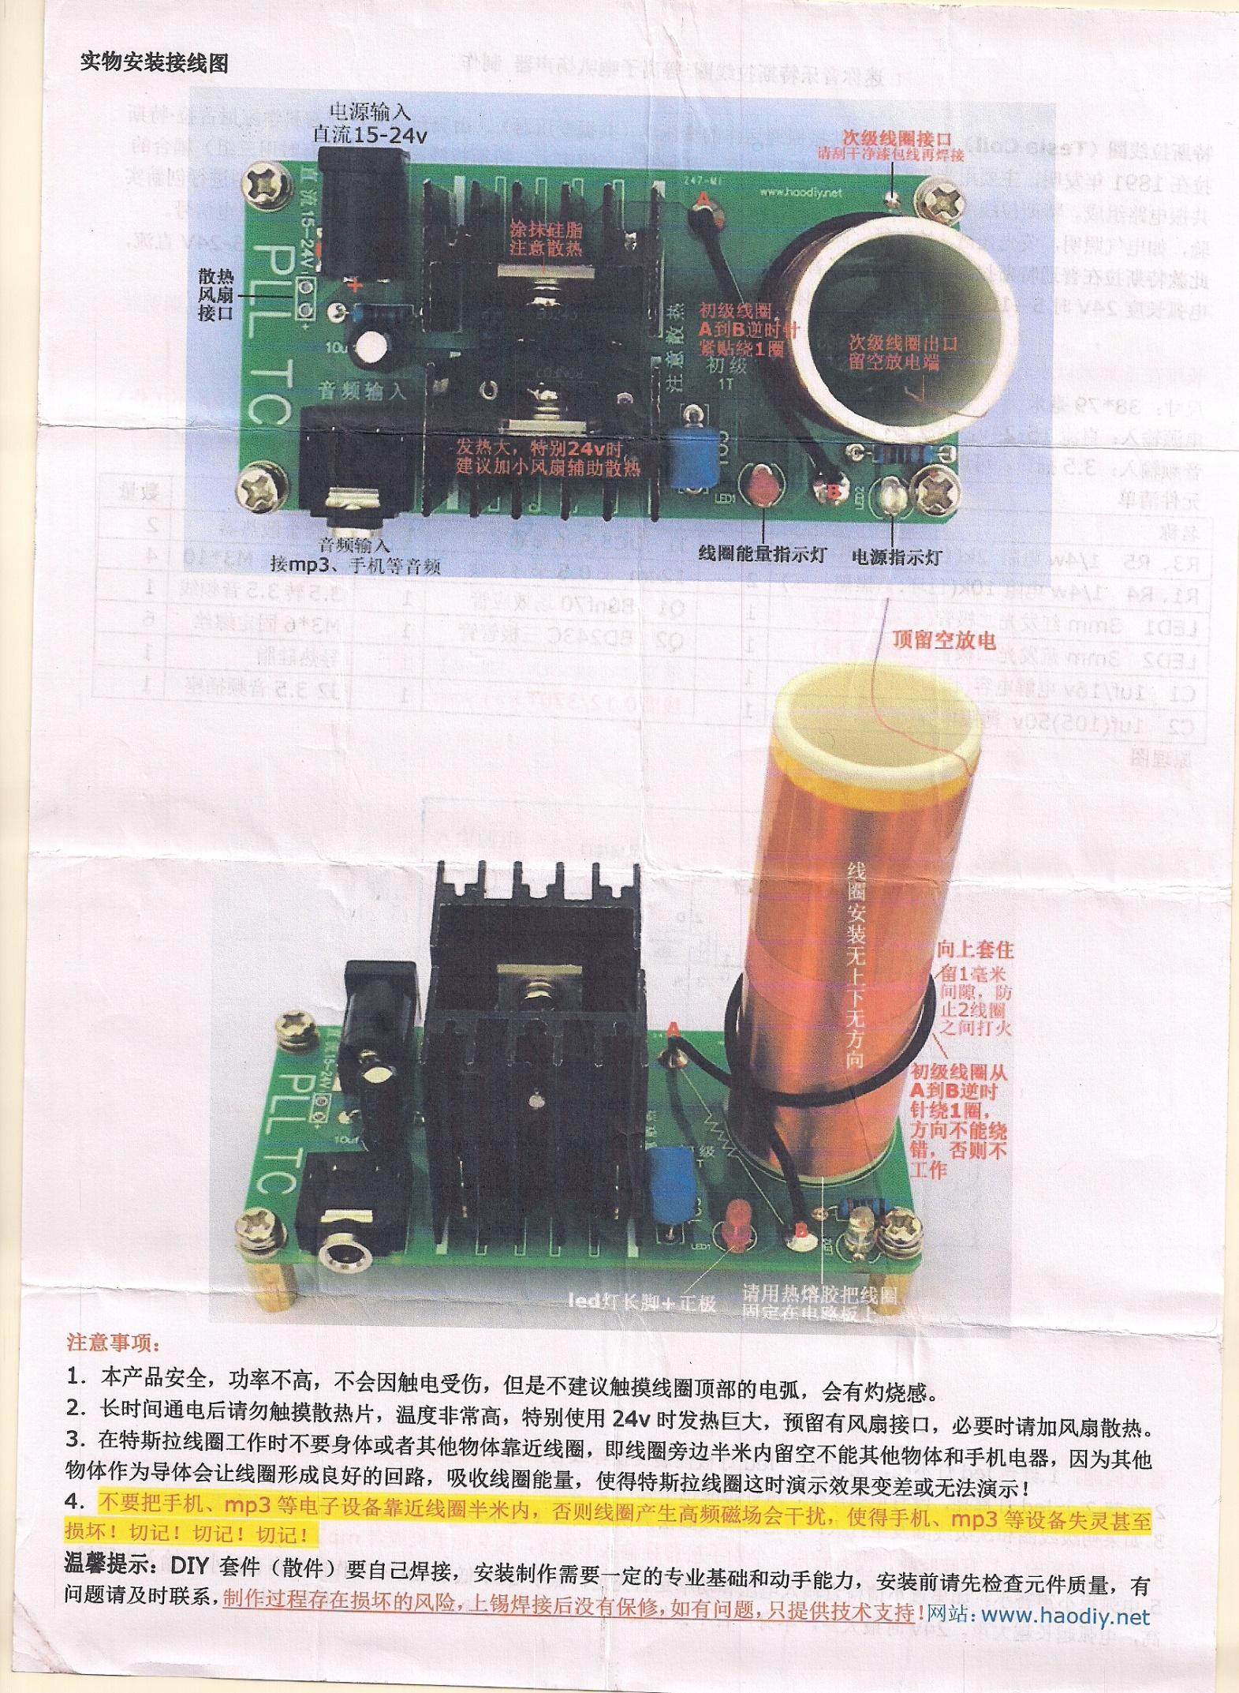

Figure 7.18 Instruction sheet for miniature Tesla Coil

## Minutes and Agenda

## Procurement

## Feedback sheets from Faraday Event